



**Development and Evaluation for Amazing Sport Yoga**

Unit 1: Programming



Yoon Mi Mi Oo

HND 29th Batch

Youth International University

Contents

P4. 2

Source code 4

Testing the source code 17

P5. 30

Debugging 30

Debugging facilities 30

Breakpoints 30

Integrated Debugger 30

Variable and call stack inspection 31

P6. 32

Coding standards 32

Naming conventions 32

Indentation and formatting standards 33

Version Control 33

M3. 35

Possible errors when changing code 36

Usage of radix sort in the program 37

M4. 40

D3. 41

IDE 41

Effects of using IDE 41

Effects without IDE 41

IDE comparison 41

D4. 42

Role and purpose of a coding standard in a team 42

Role and purpose of a coding standard as an individual 42

References 44

# P4.

The program to manage yoga training plans and customers mainly constitutes of three class. Classes act as blueprint for the objects to be created consistently. First class is the Training Plan.

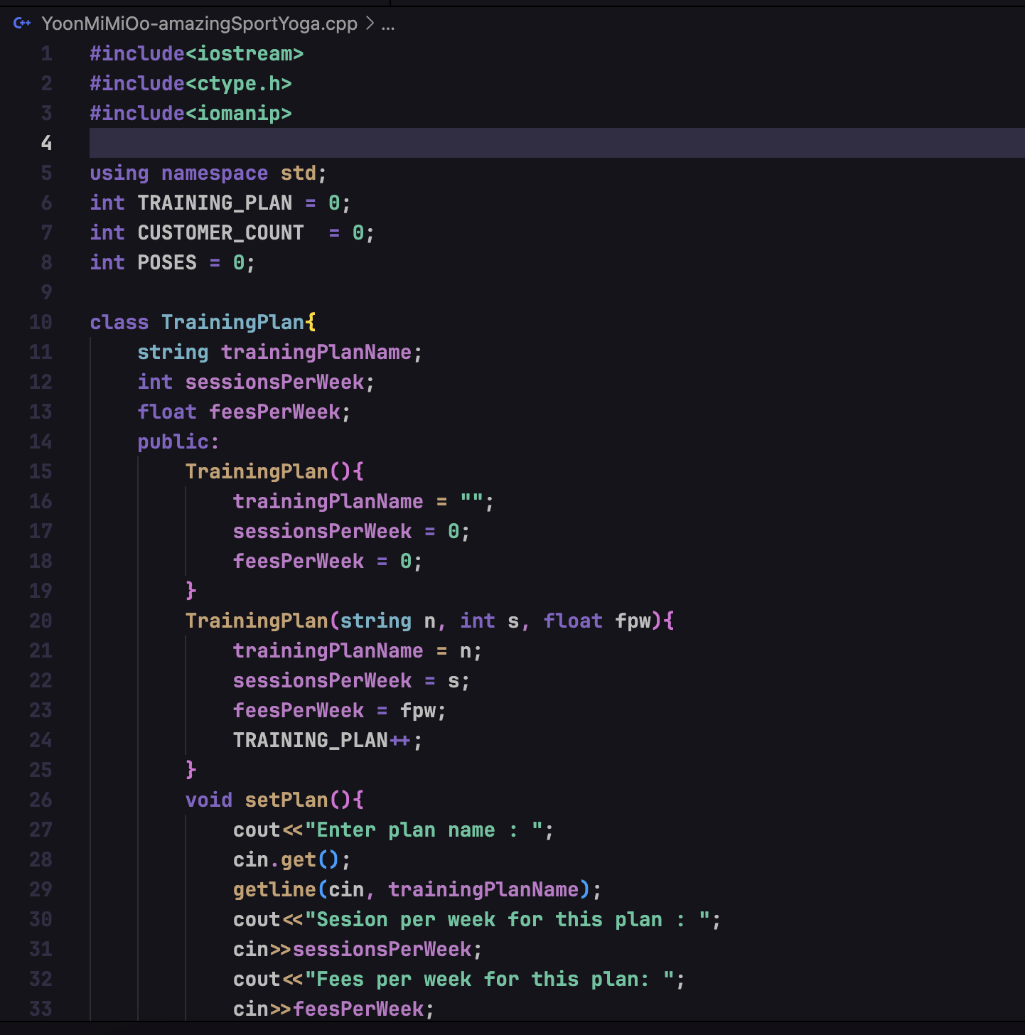

Figure – training plan class

Training plan class contains plan name, sessions per week and fees per week. It contains methods to create, update, display training plans.

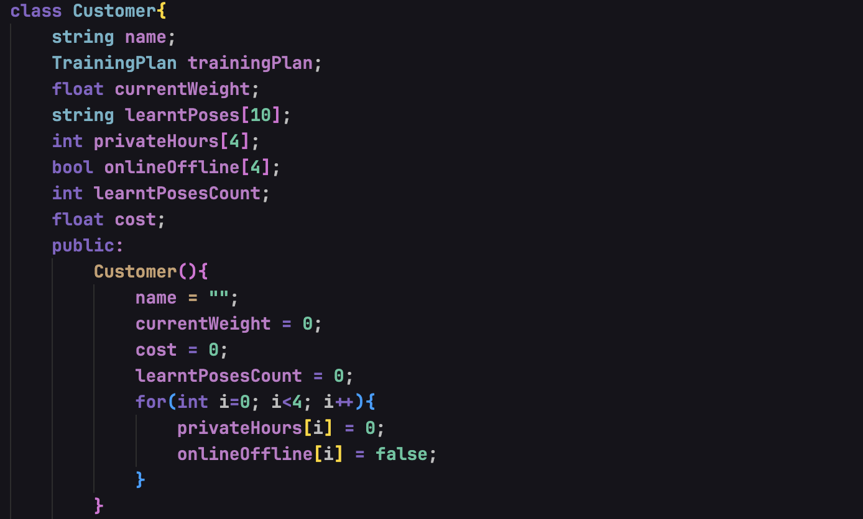

Figure – Customer class

Second class of the program, Customer class, contains all the information of customers to be stored in the variables. It contains the name, training plan, learnt poses if there is any, private hours, private hour online or offline status and learnt poses count to calculate discounts. Methods to also register a new customer, update, view and display total costs for each customer.

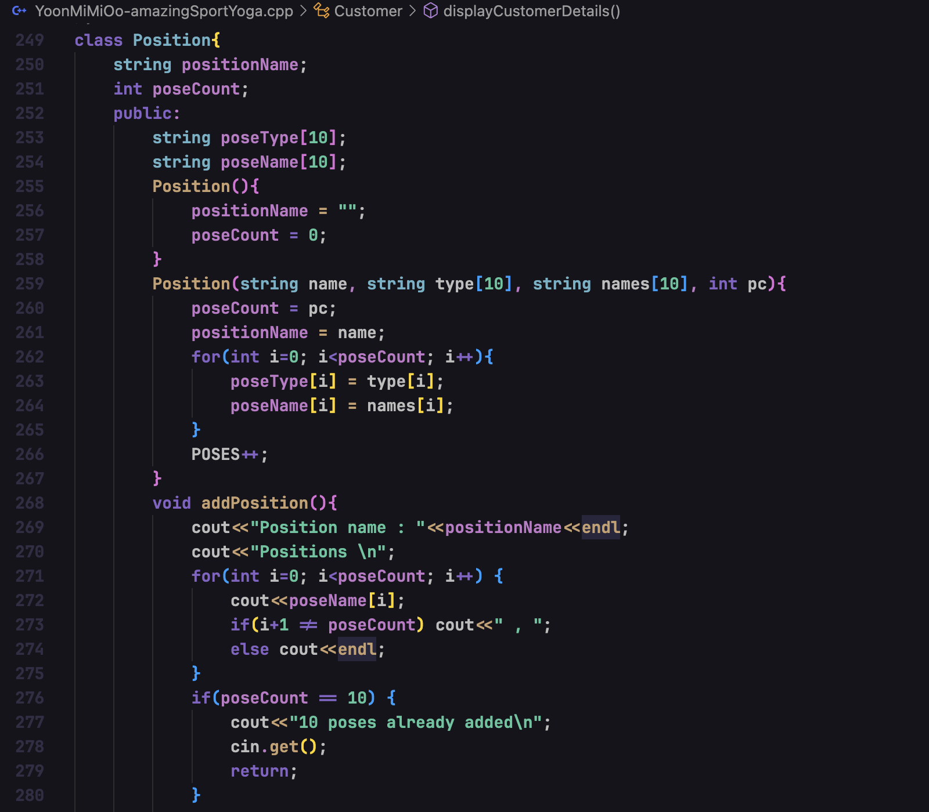

Figure – Position class

The last class of the system, position class, contains information about position names, pose counts stored in the arrays of pose names and pose types. Admin can create new pose plan, add new pose names and types to existing plan and display the plans.

## Source code

The source code for the system to manage the yoga plans and customer can be seen as below:



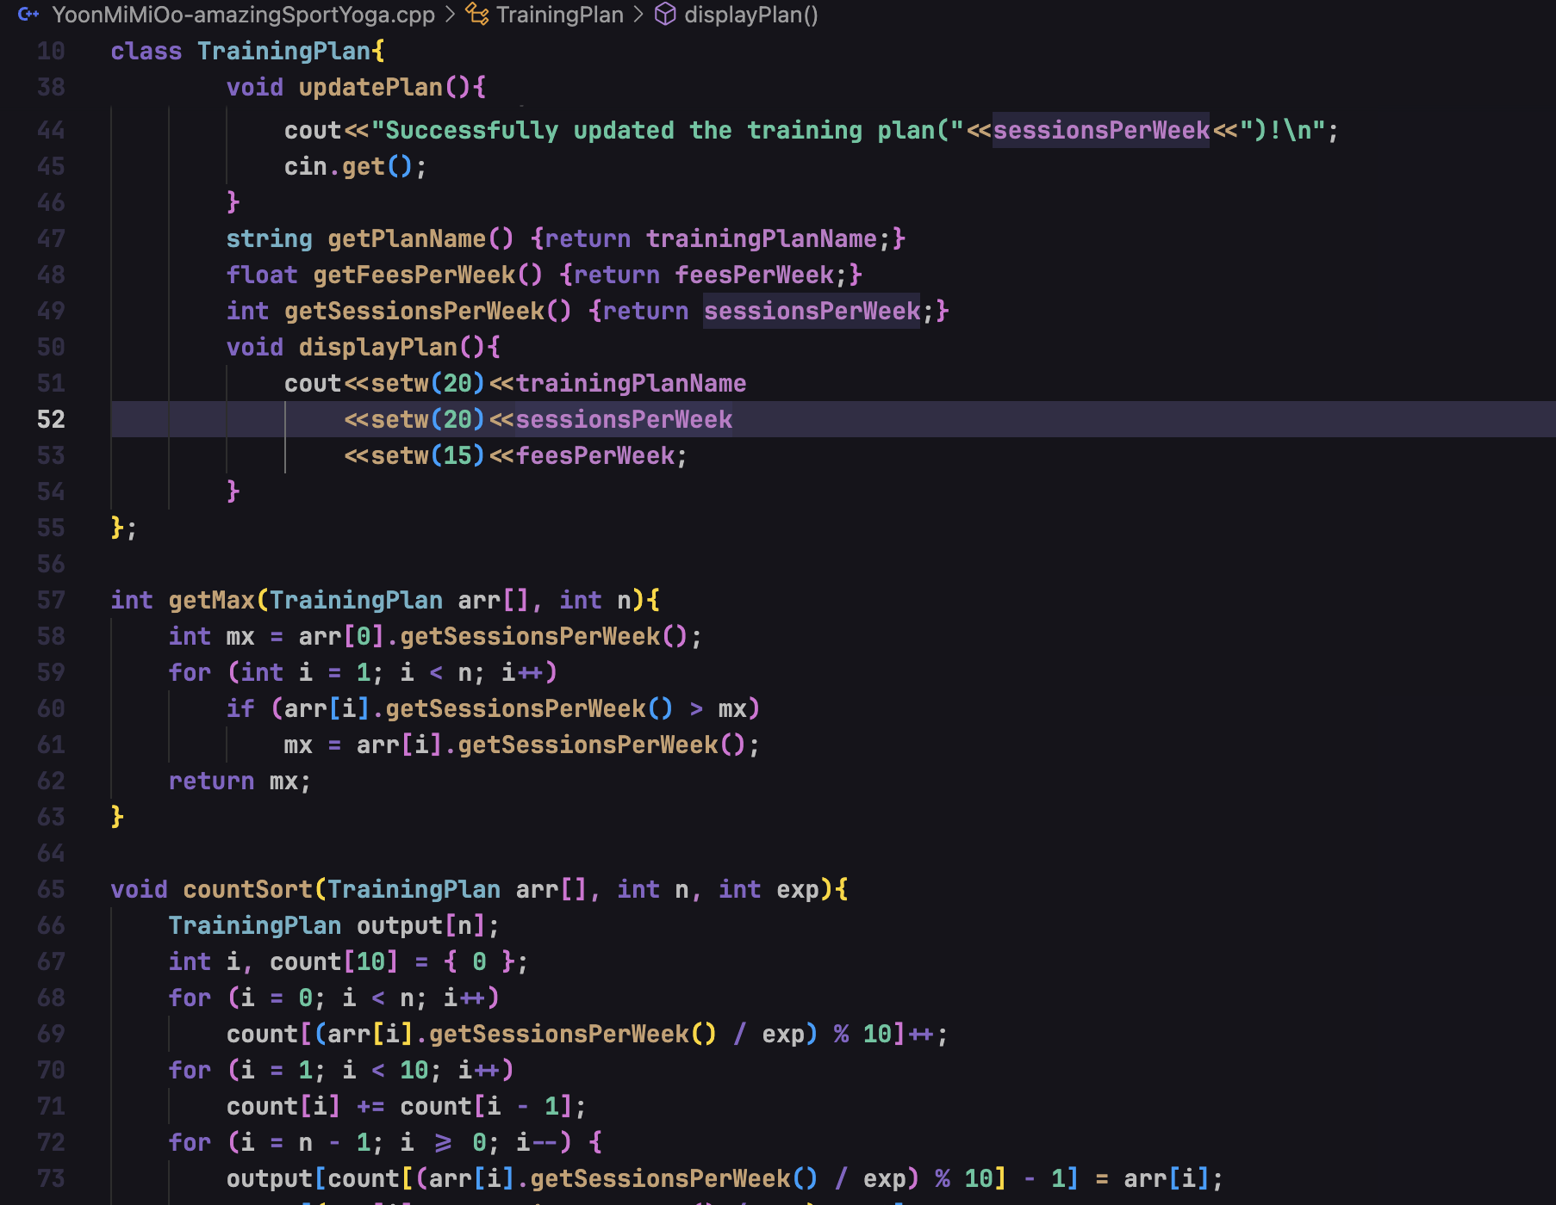

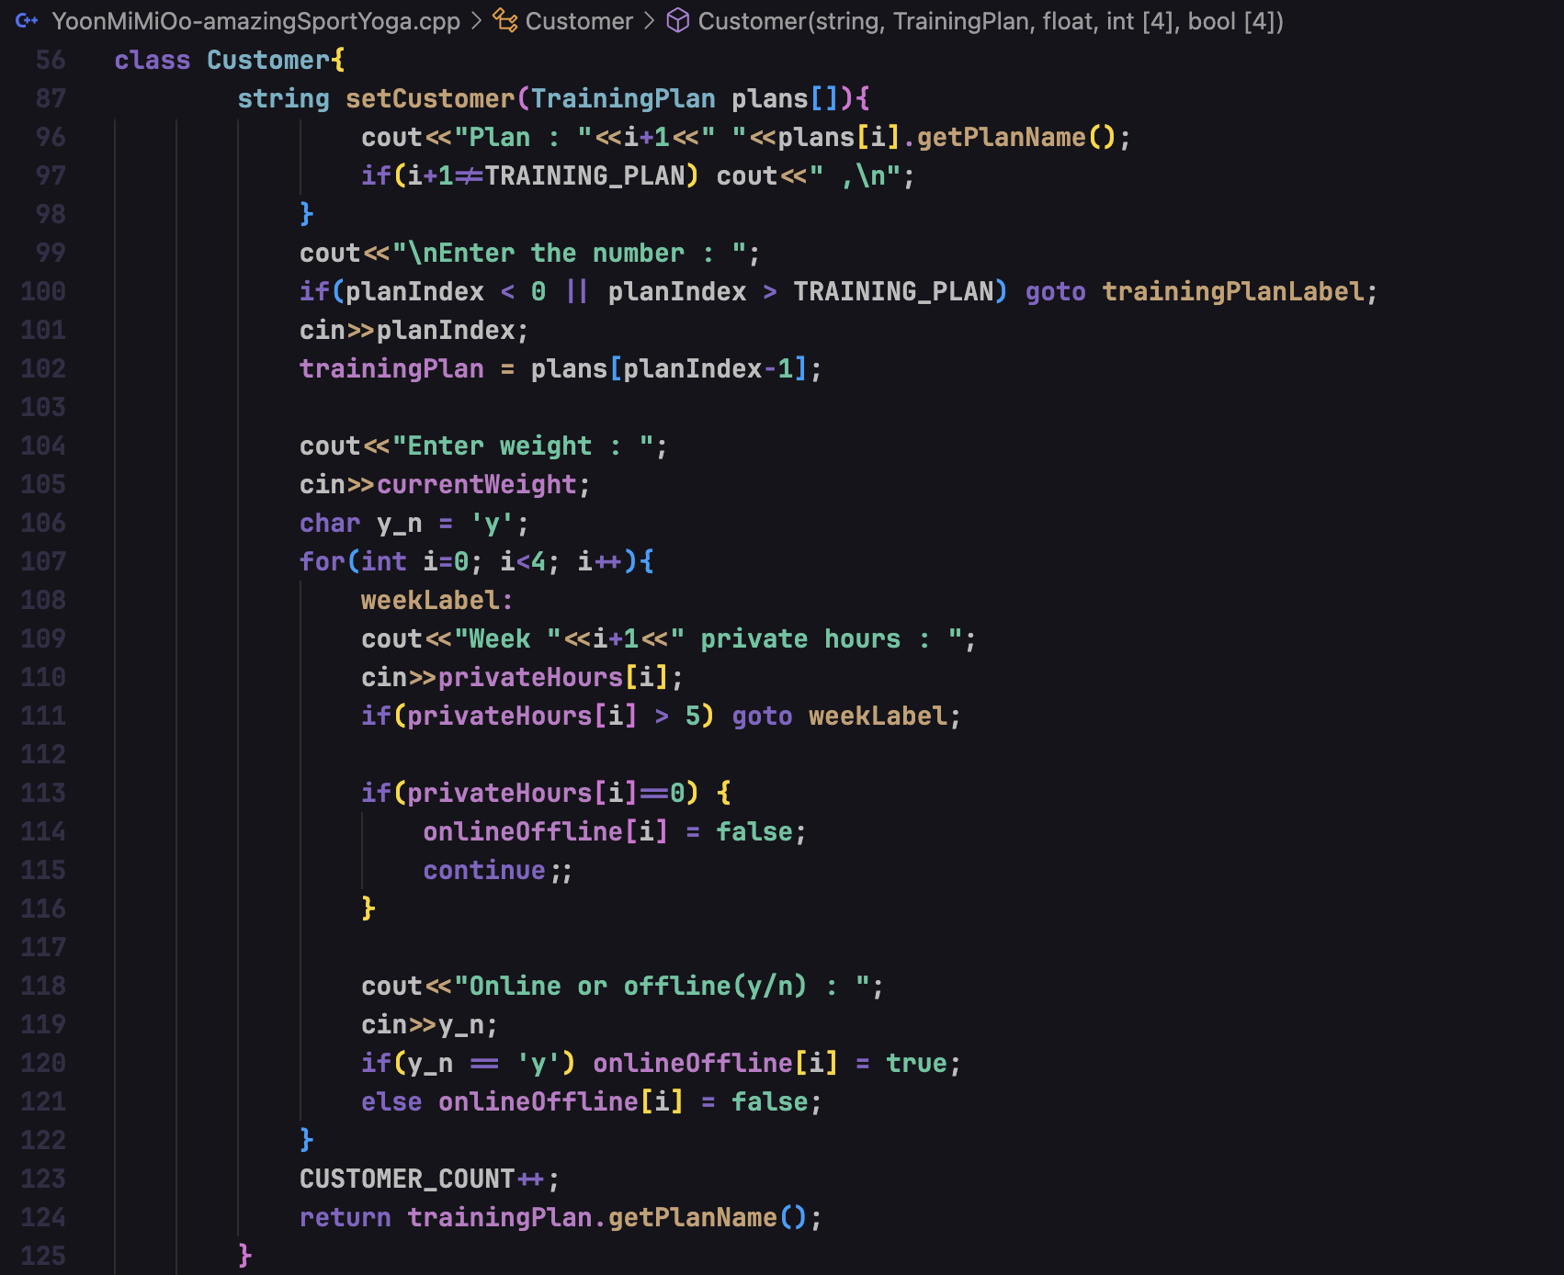

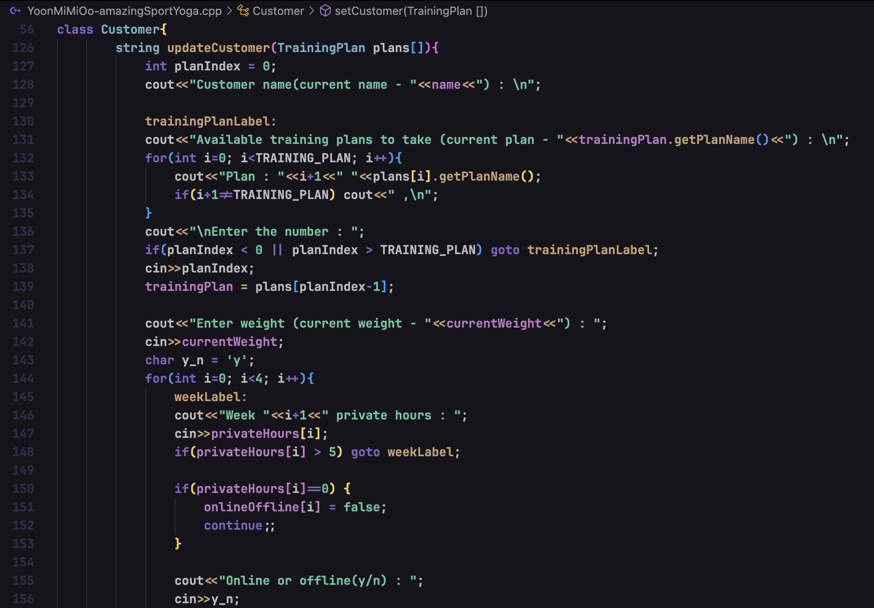

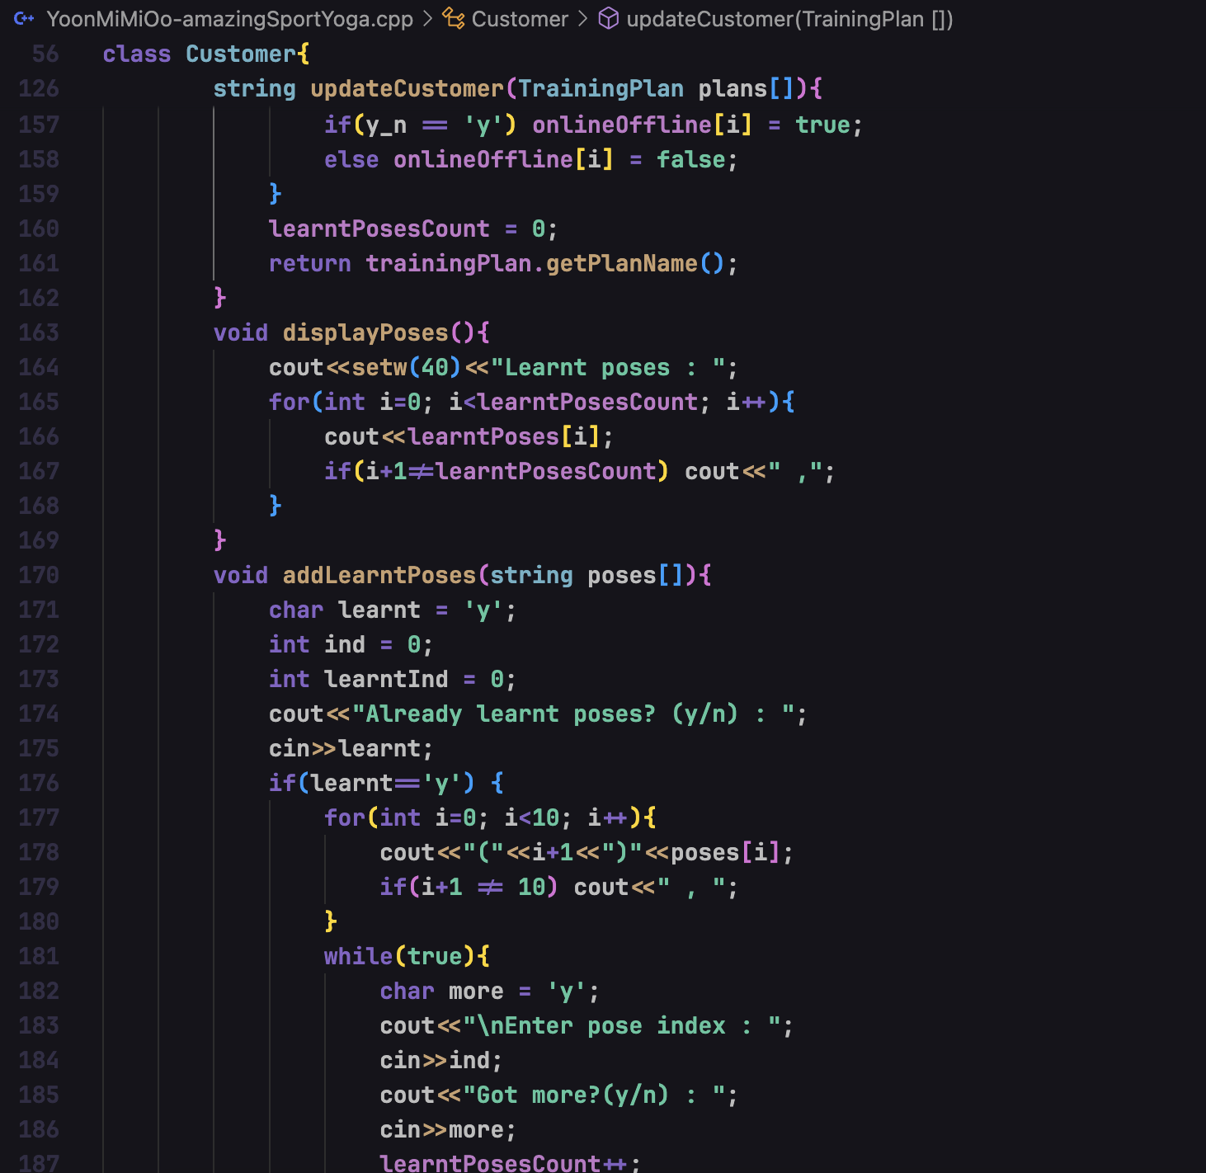

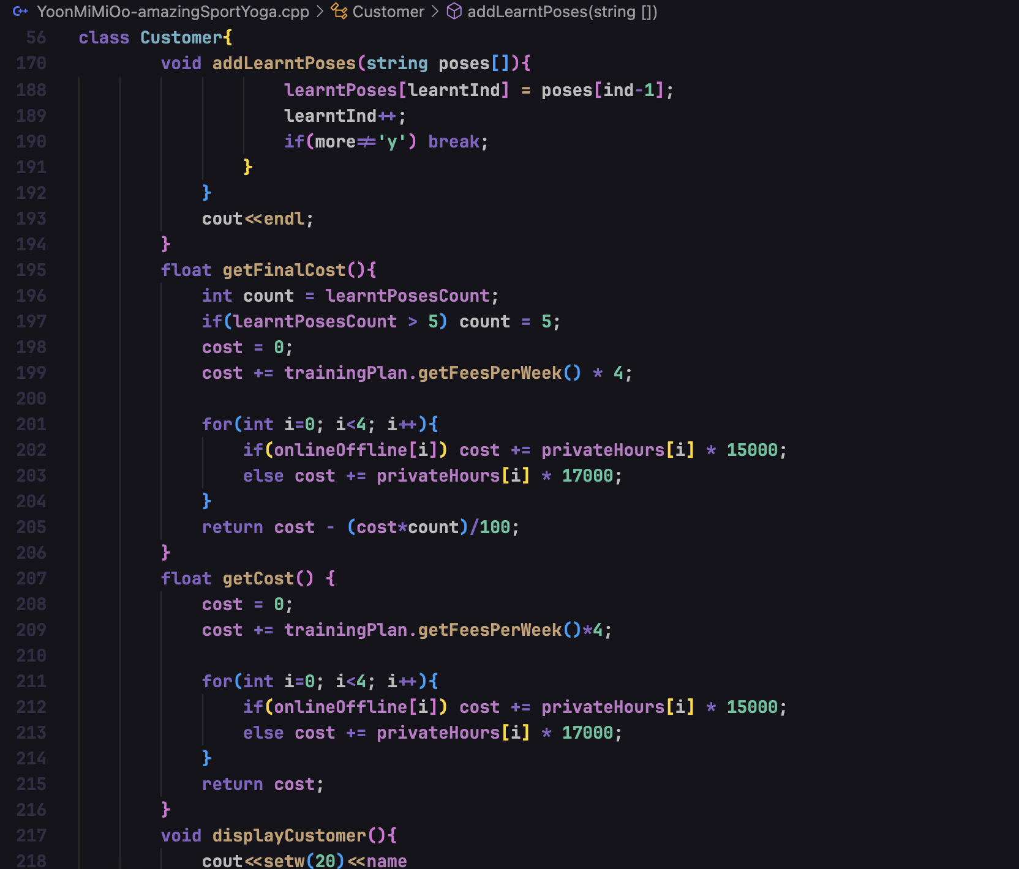

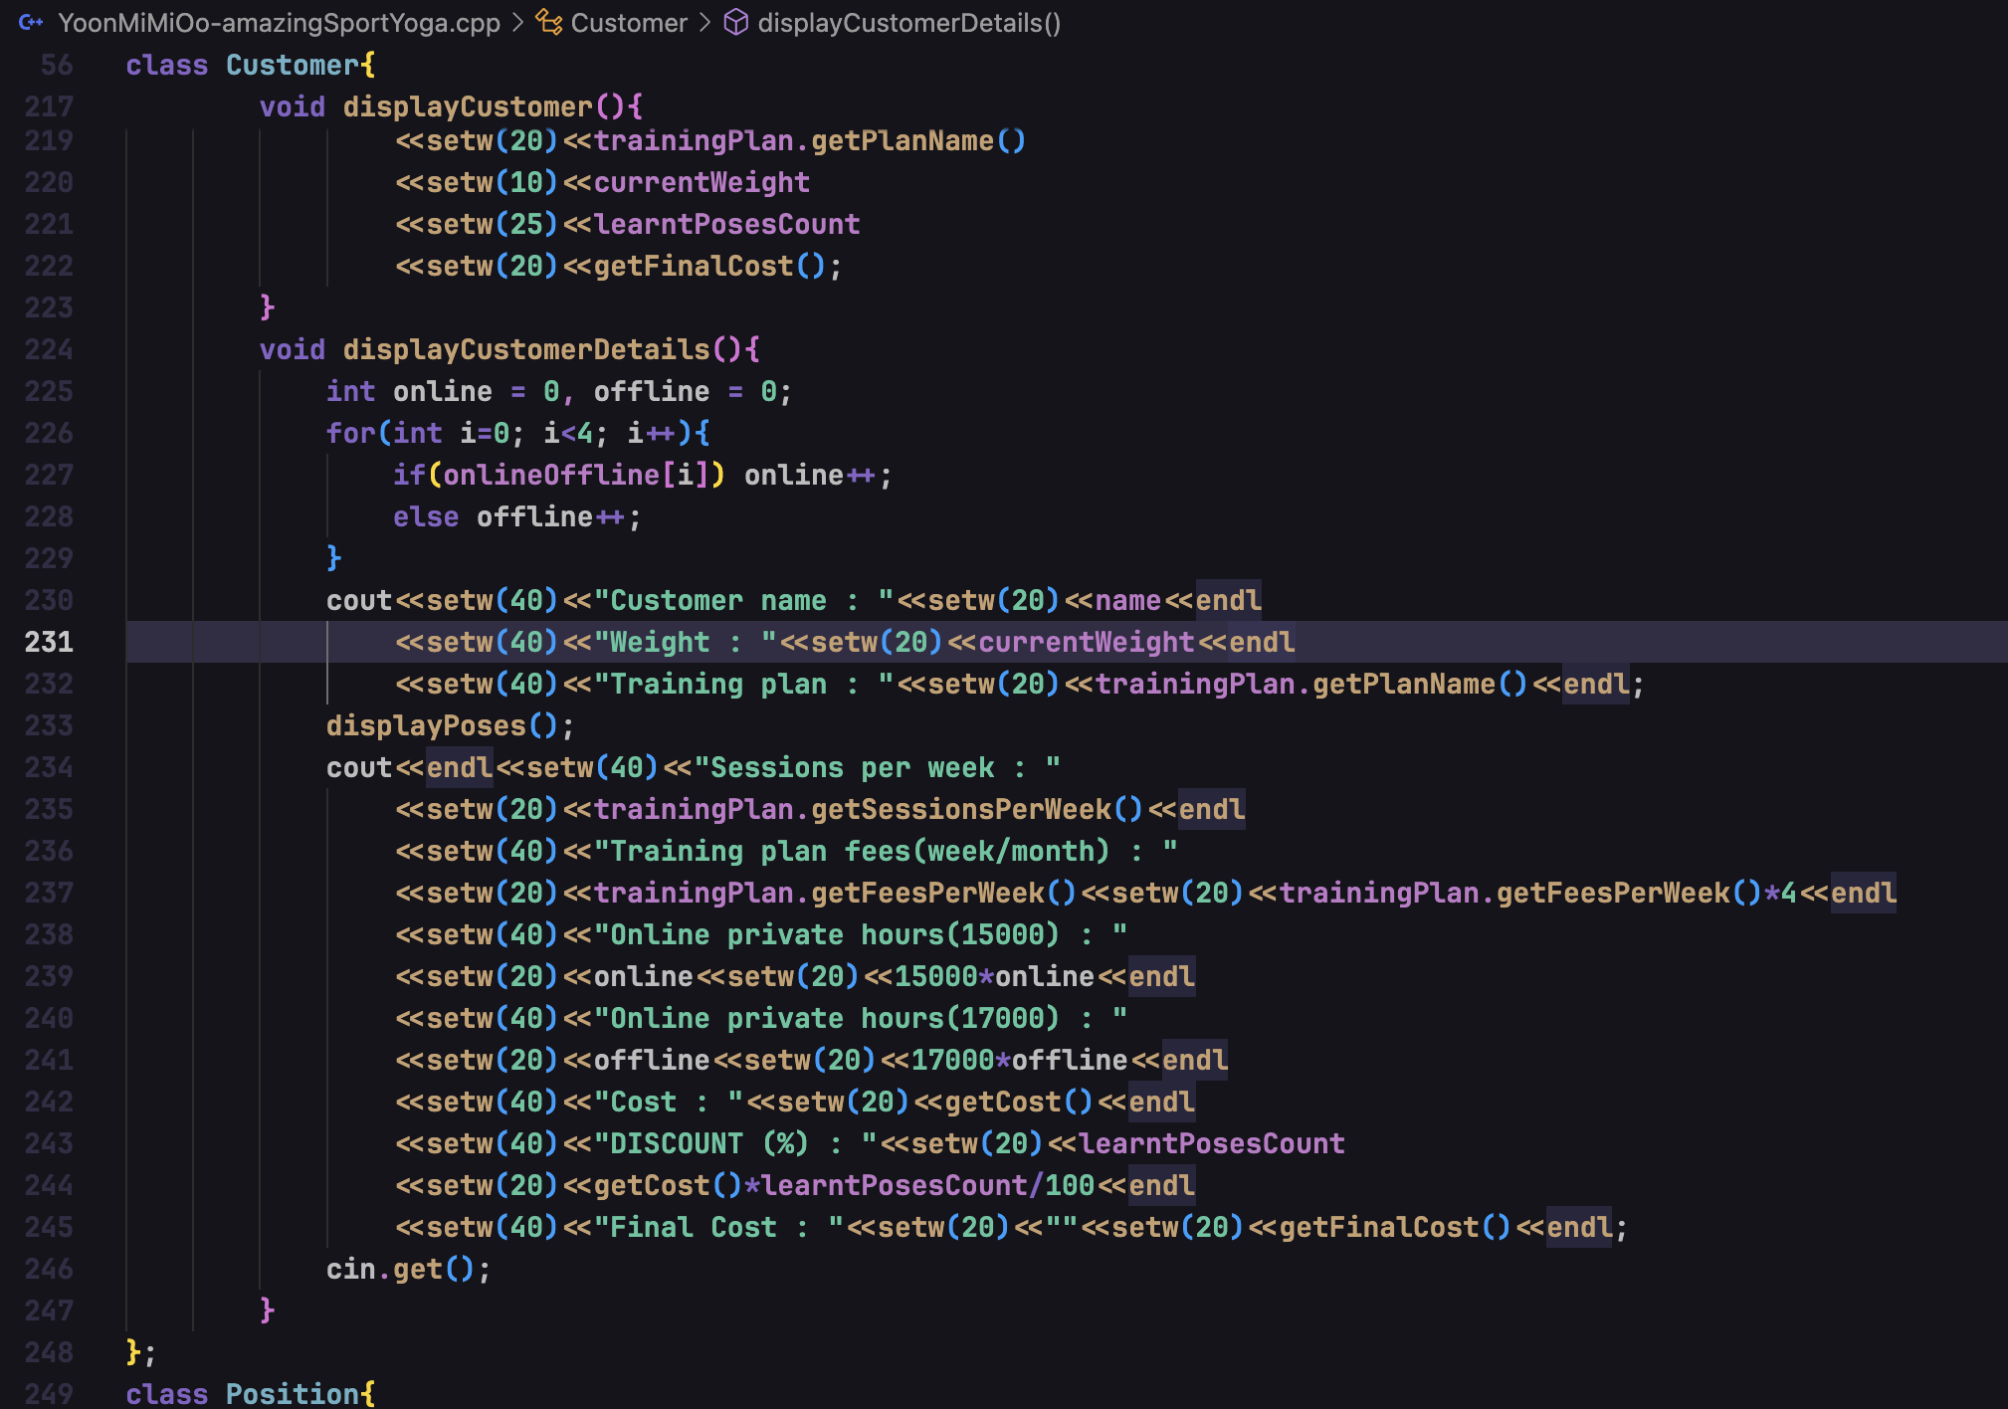



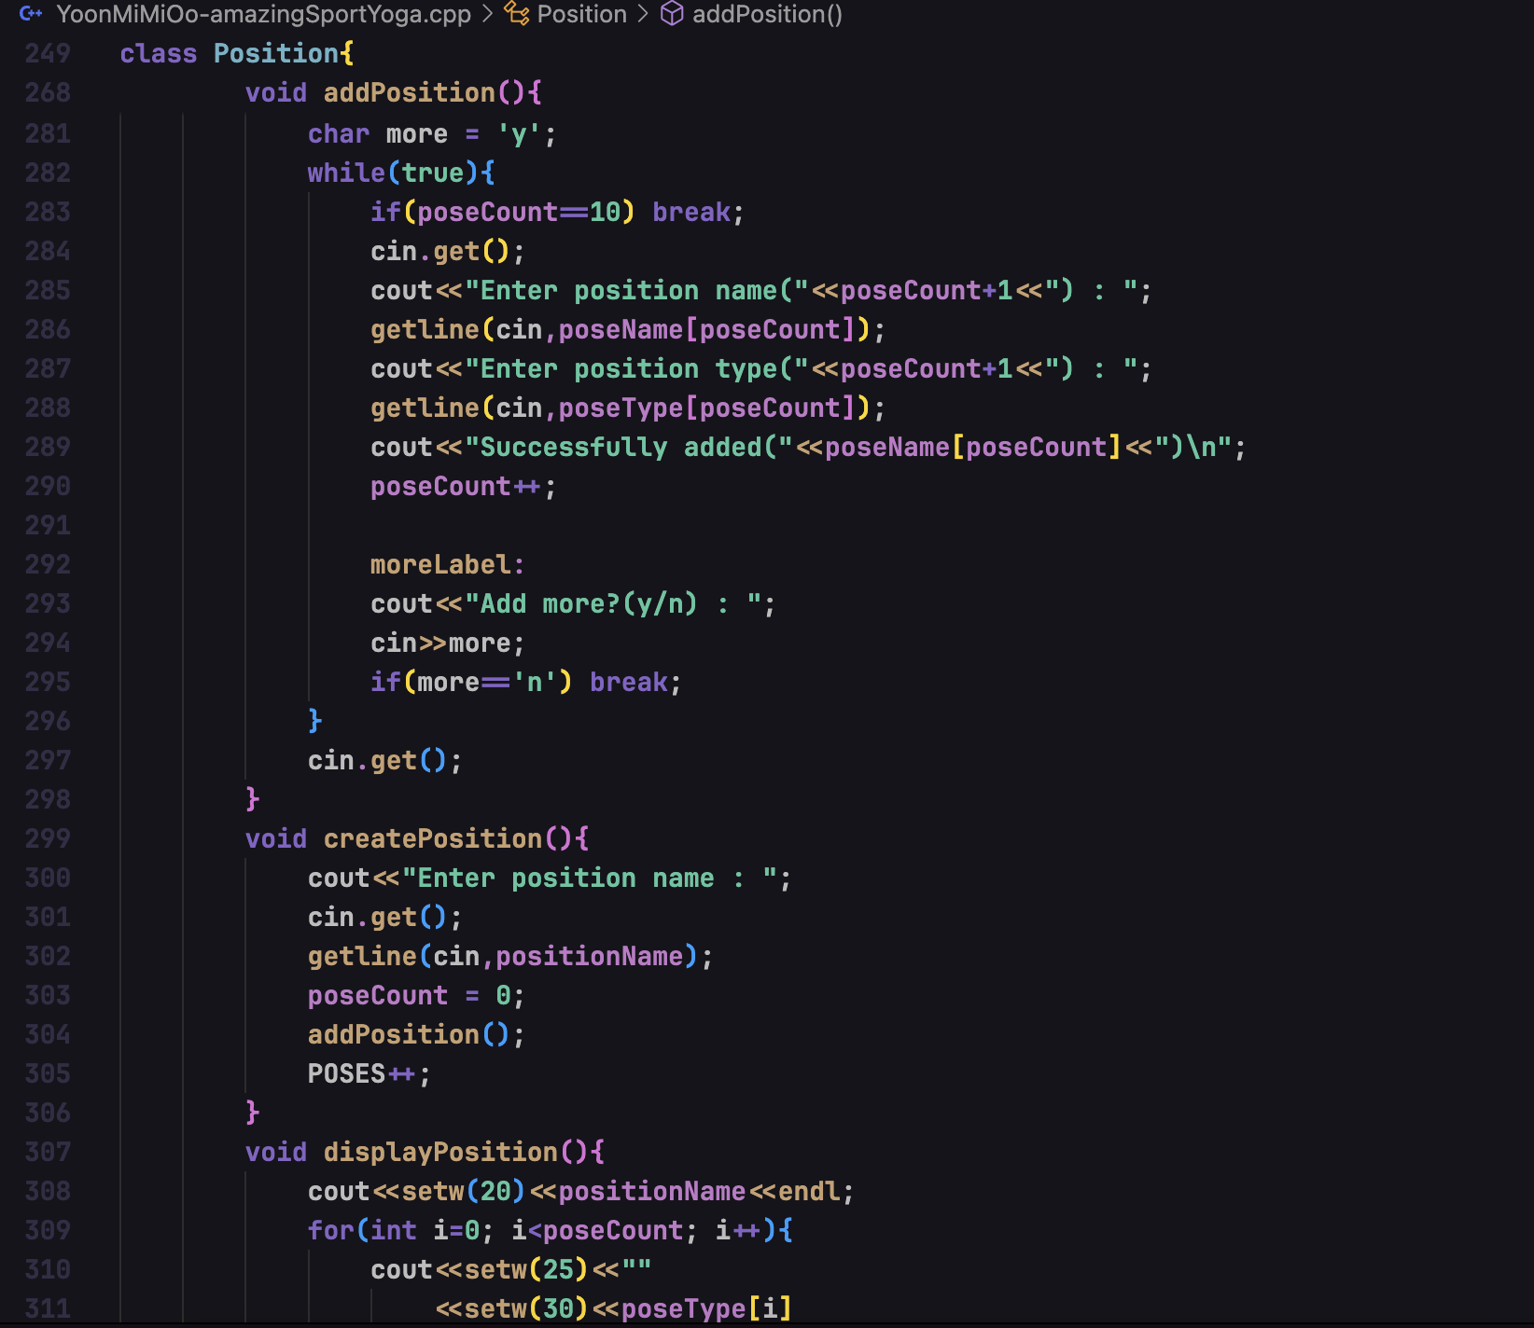

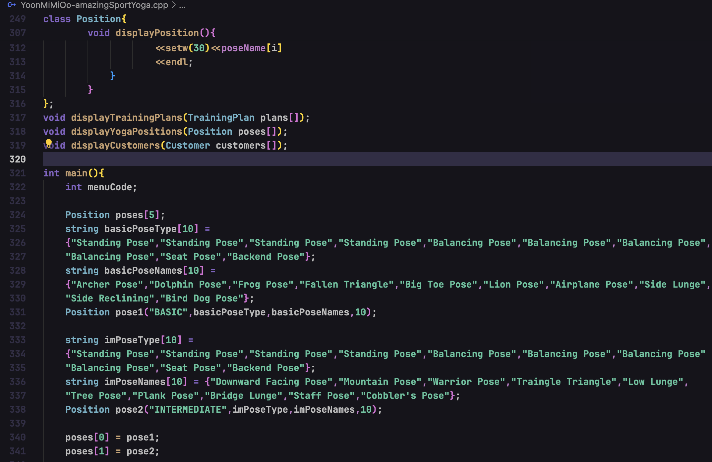

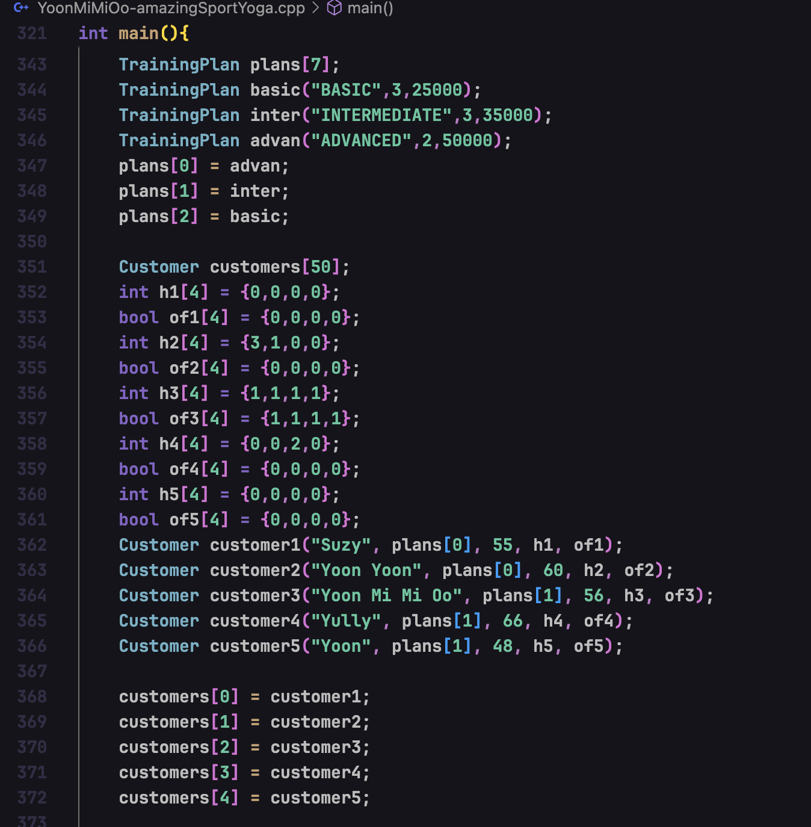

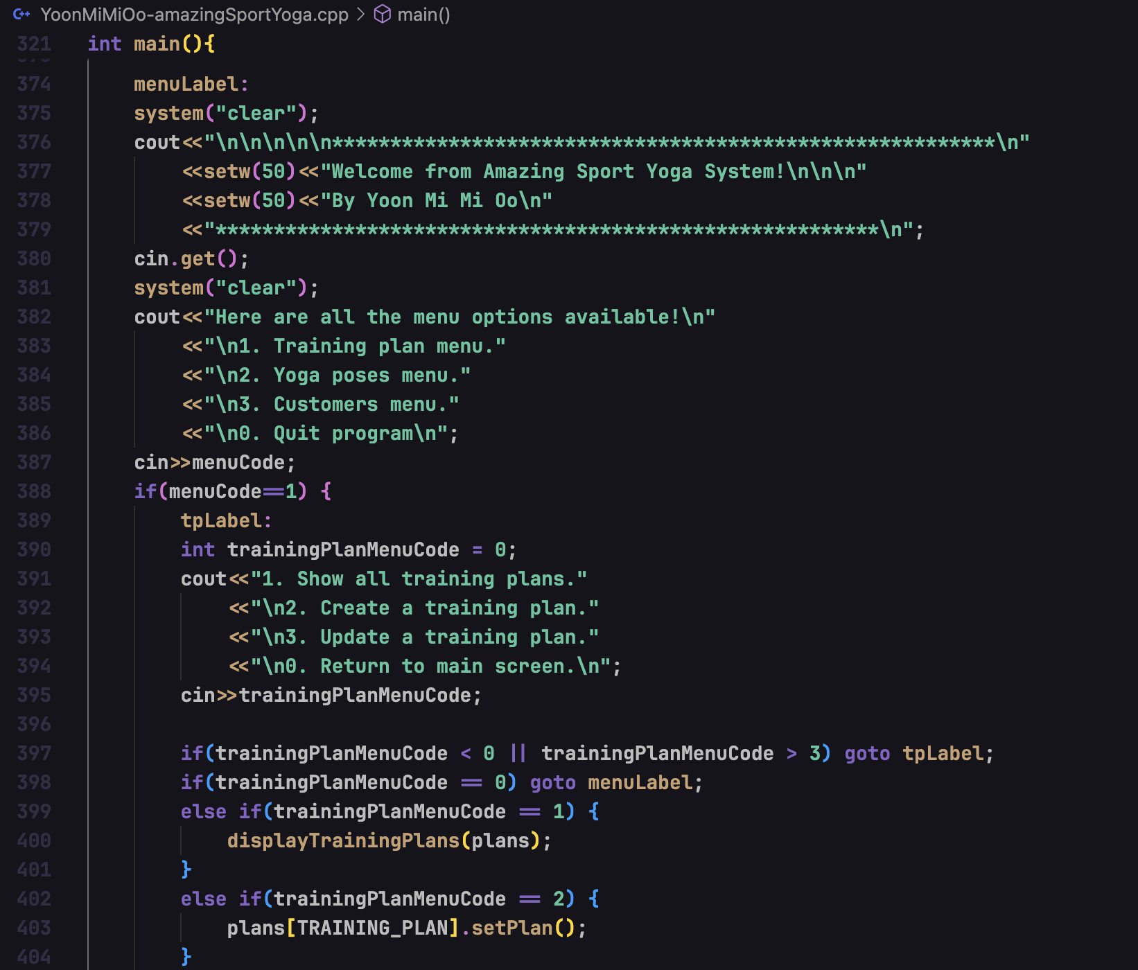

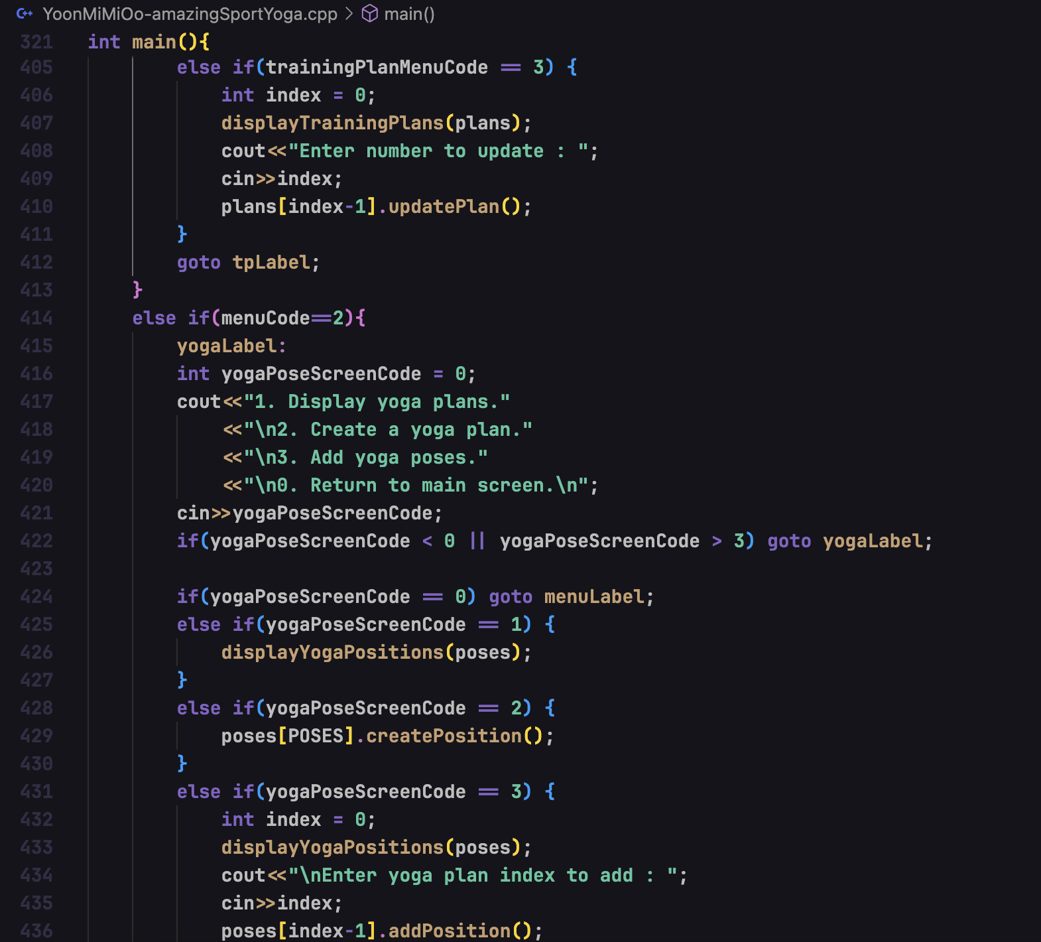

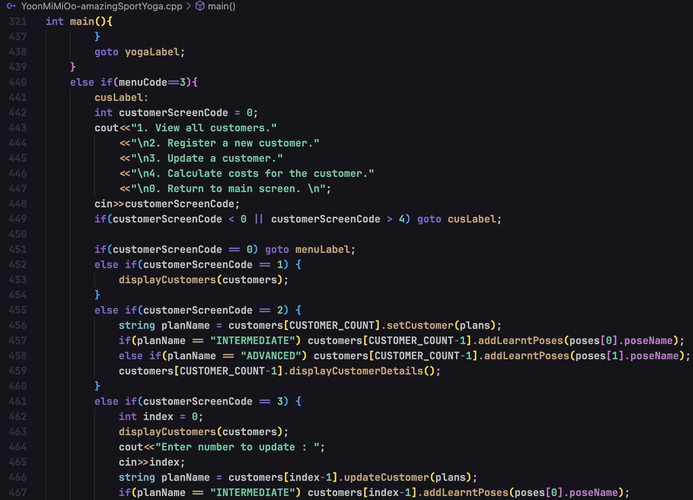

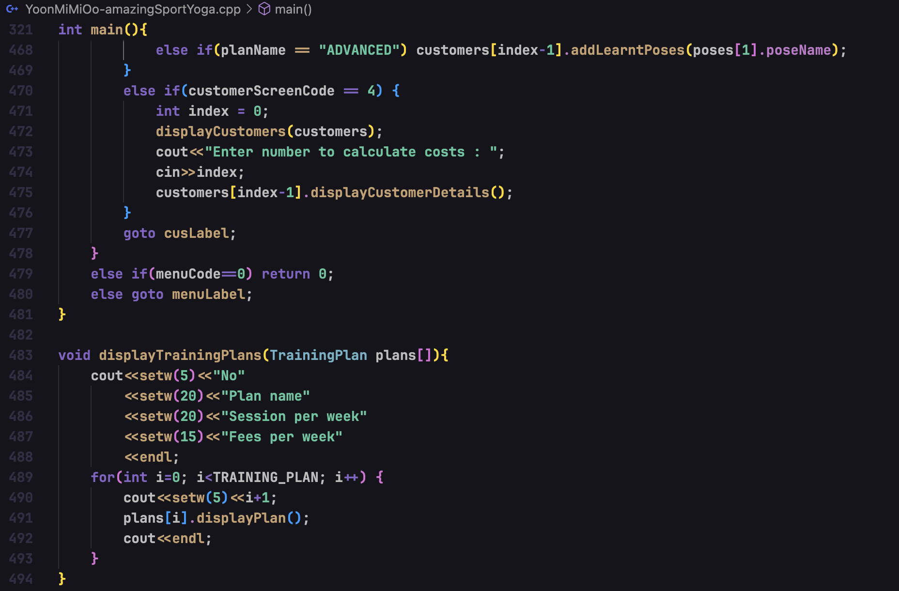

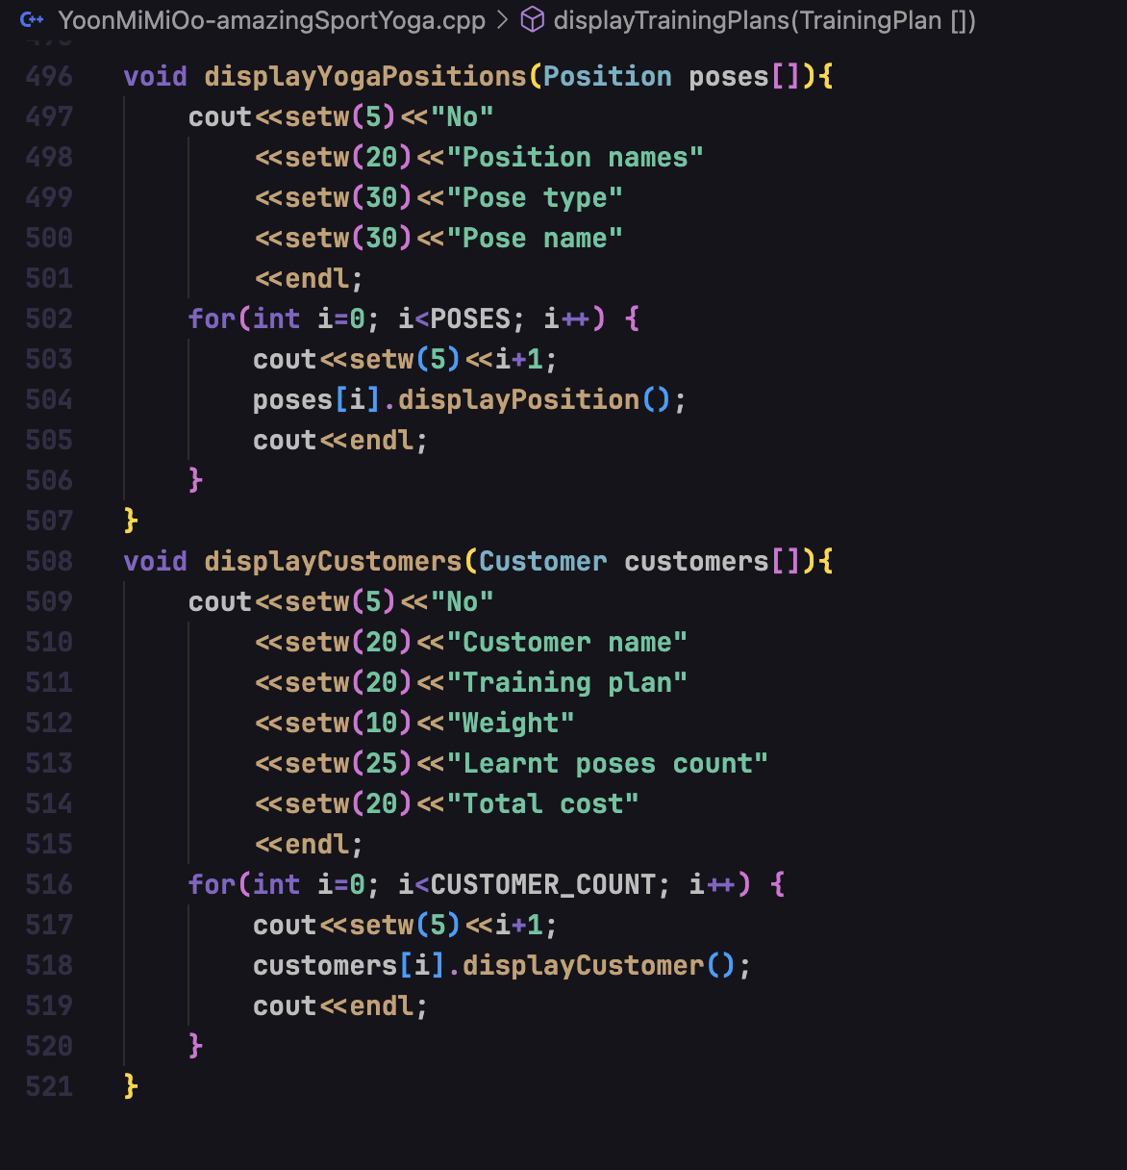

## Testing the source code

After compiling and running the code, the results can be seen as below.

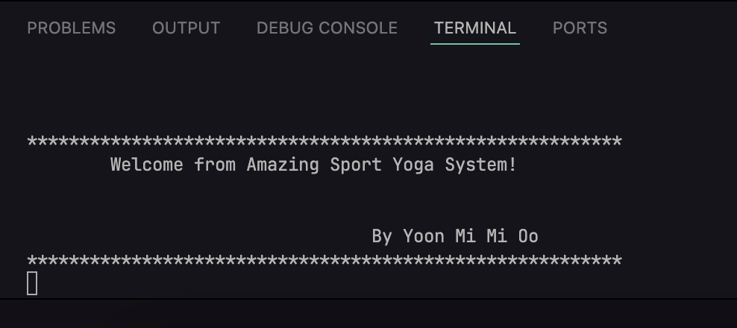

Figure – welcome screen

Firstly, it greets the user with welcome message and developer’s name.

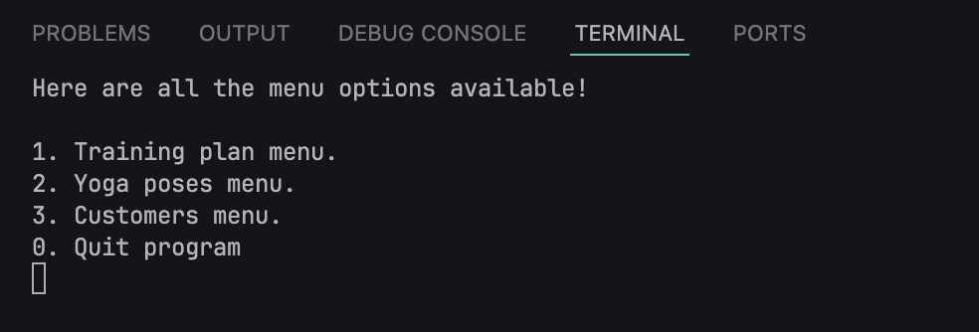

Figure – menu options

Secondly, it shows the menu options available in the system.

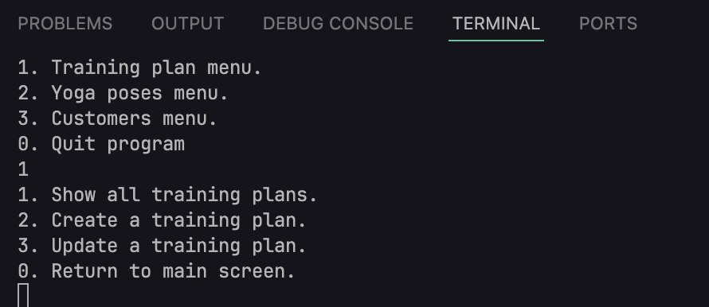

Figure – training plan menu

Users can enter valid options to enter into each menu. In the above picture, training plan menu and its available options are displayed.

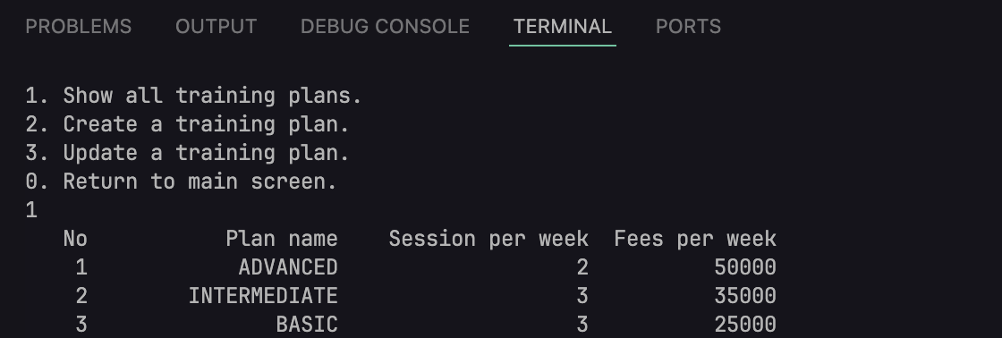

Figure – displaying all training plans

Admins can view all the plans available in the system by entering menu number 1.

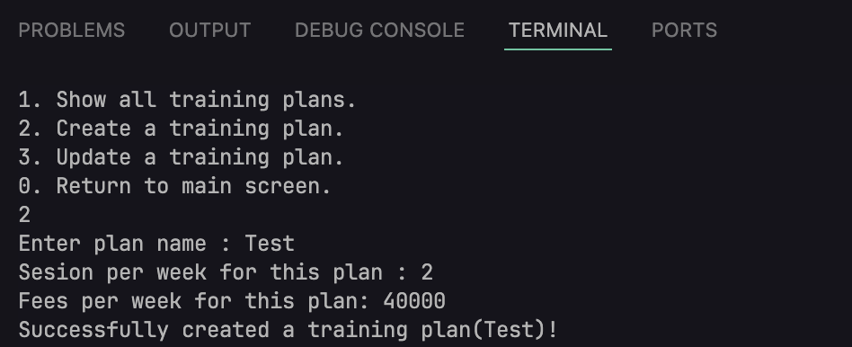

Figure – registering new training plan

New plan can also be created by choosing menu number 2. It will prompt the required fields for the plan.

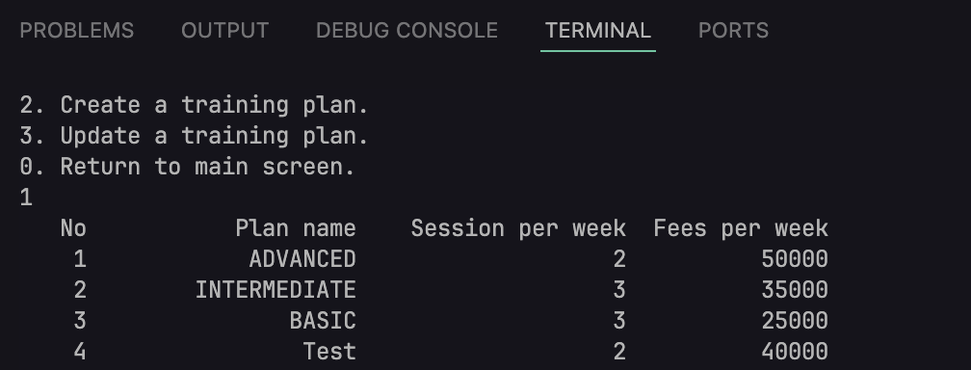

Figure – viewing training plan after adding a new plan

After adding a plan, the plan lists can be seen updated in the above picture.

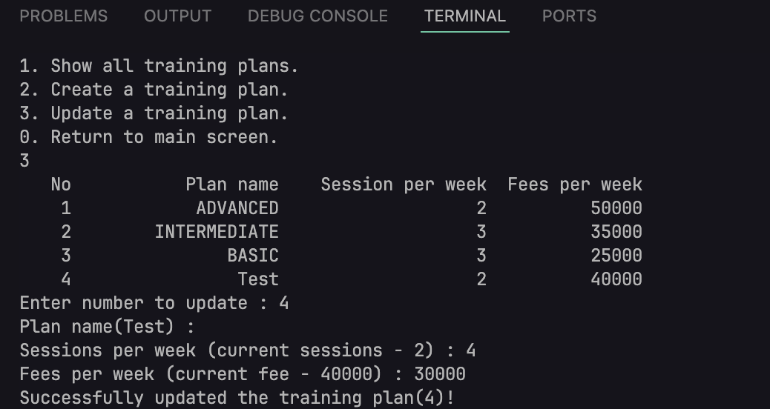

Figure – updating training plan

Admins can also update the plan in a similar way. A table will be shown and number to updated must be inputted and all the fields except for the name will be prompted.

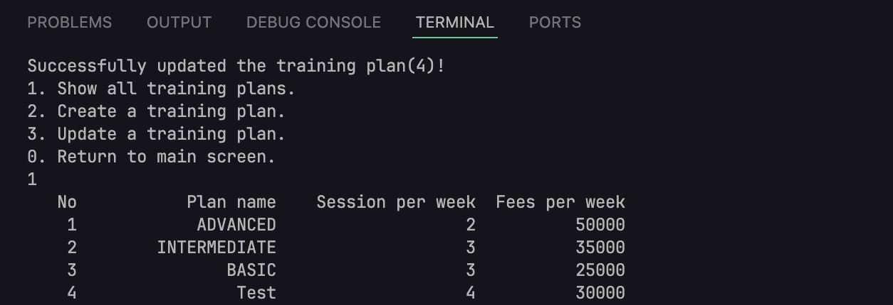

Figure – viewing training plans after updating

After updating, the list is changed.

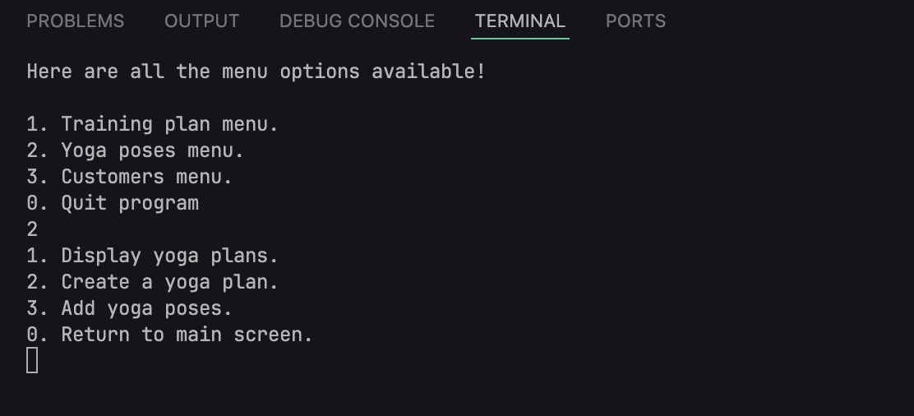

Figure – yoga plans menu

The second menu option is for managing yoga poses.

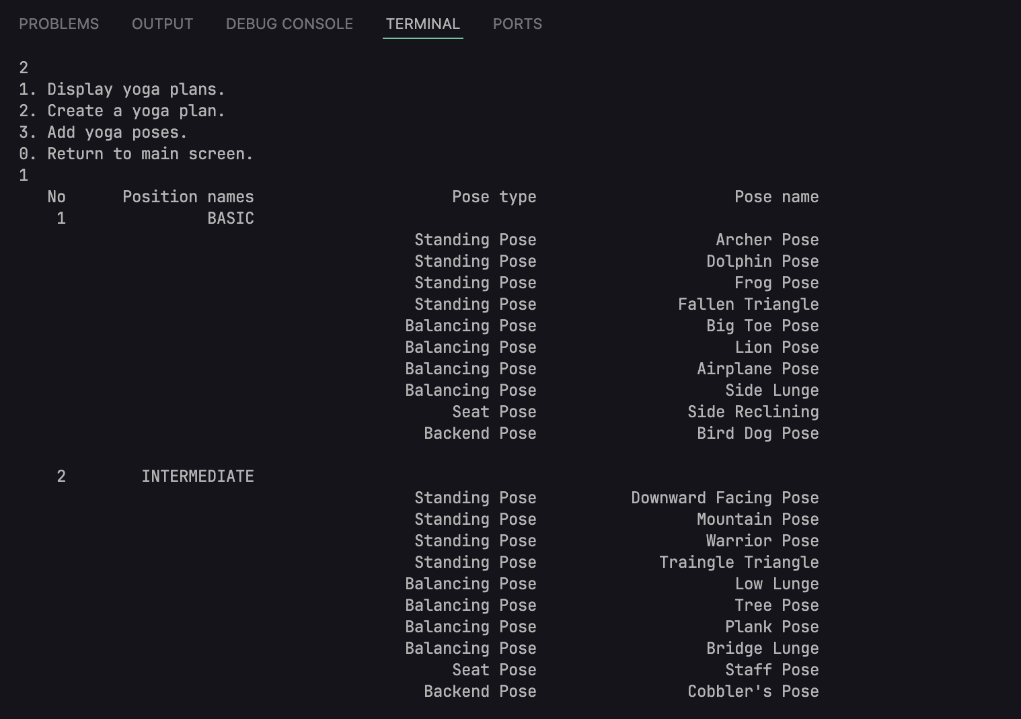

Figure – viewing yoga plans

Currently, there are two main plan added to the system.

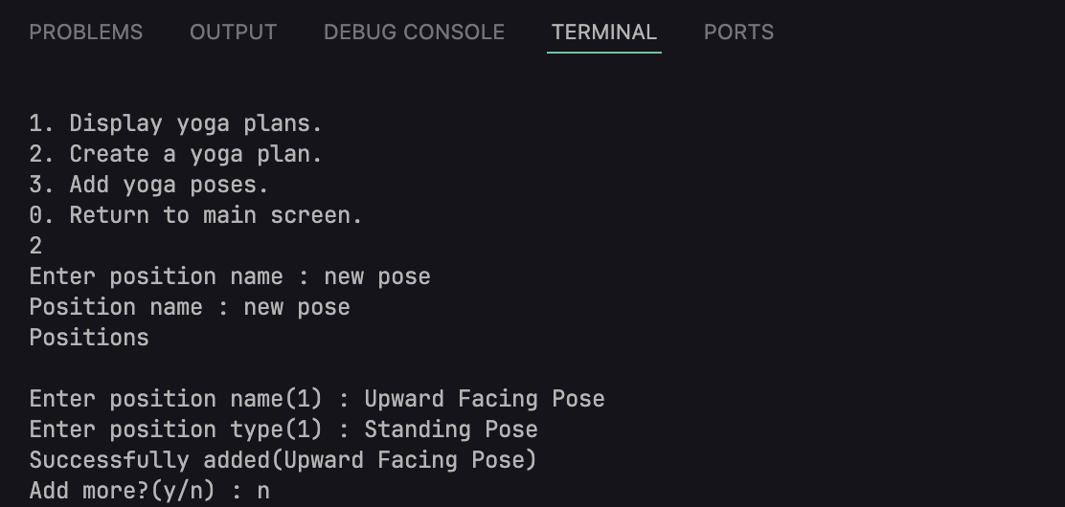

Figure – creating a yoga plan

New plan can be created using menu code 2. Position name will be firstly inputted. At least one pose name and type will be required. For more poses’ name and type, admins can input more when entered “y” to “Add more” message.

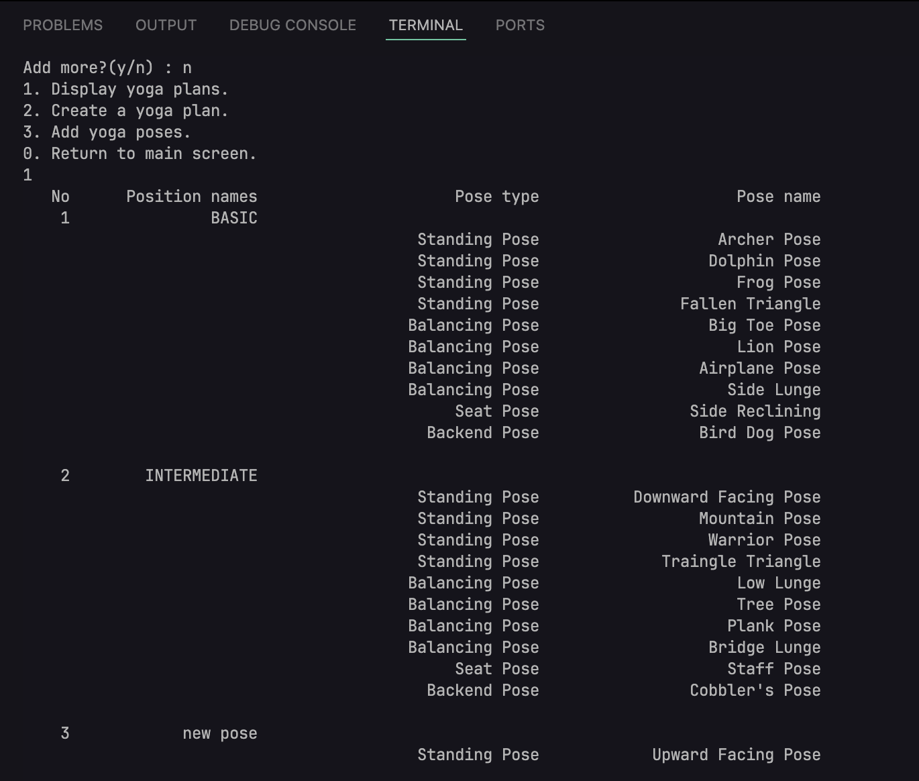

Figure – viewing training plans after creating a yoga plan

After adding a new plan, yoga plan list is updated.

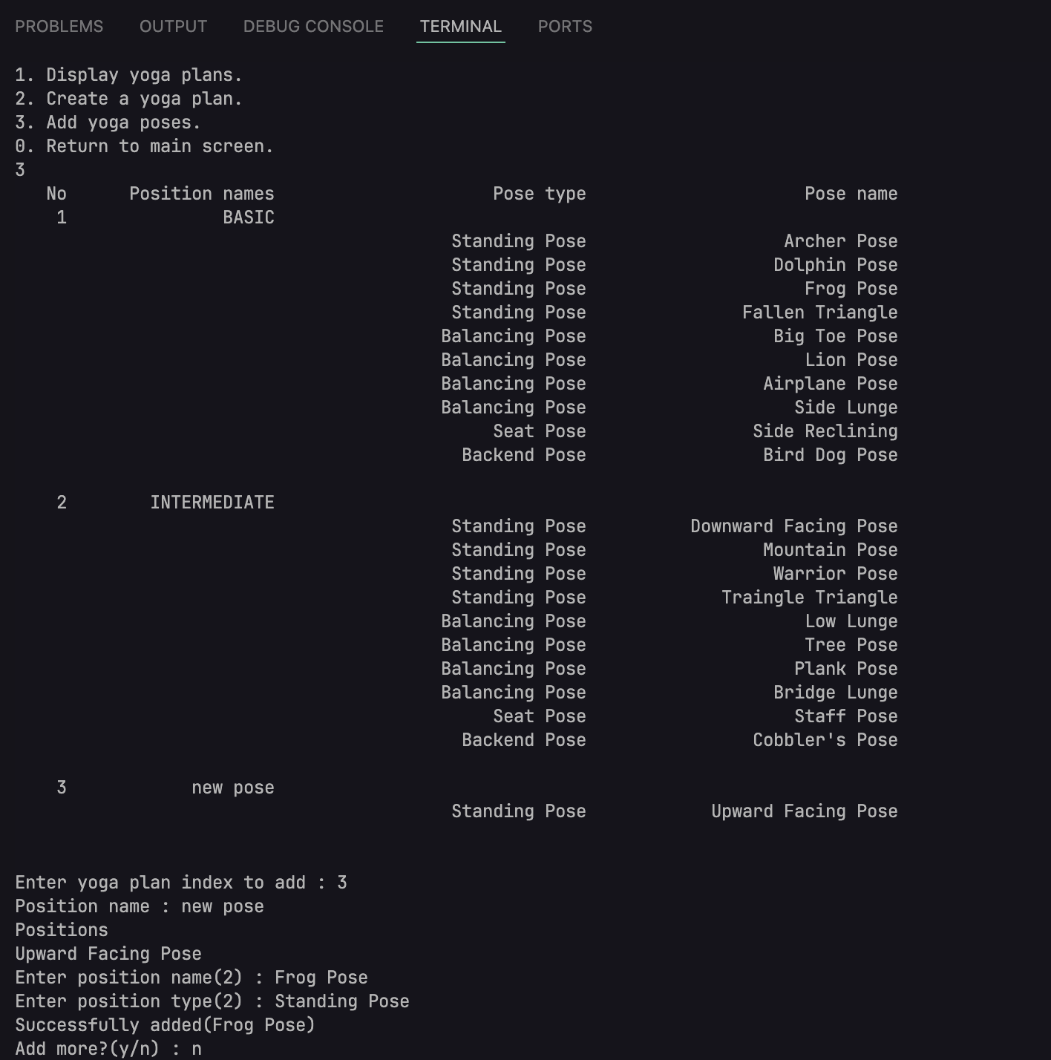

Figure – adding new pose to a yoga plan

Updating the yoga plan also follows similar process to creating one. Admin can add as much poses as they want.

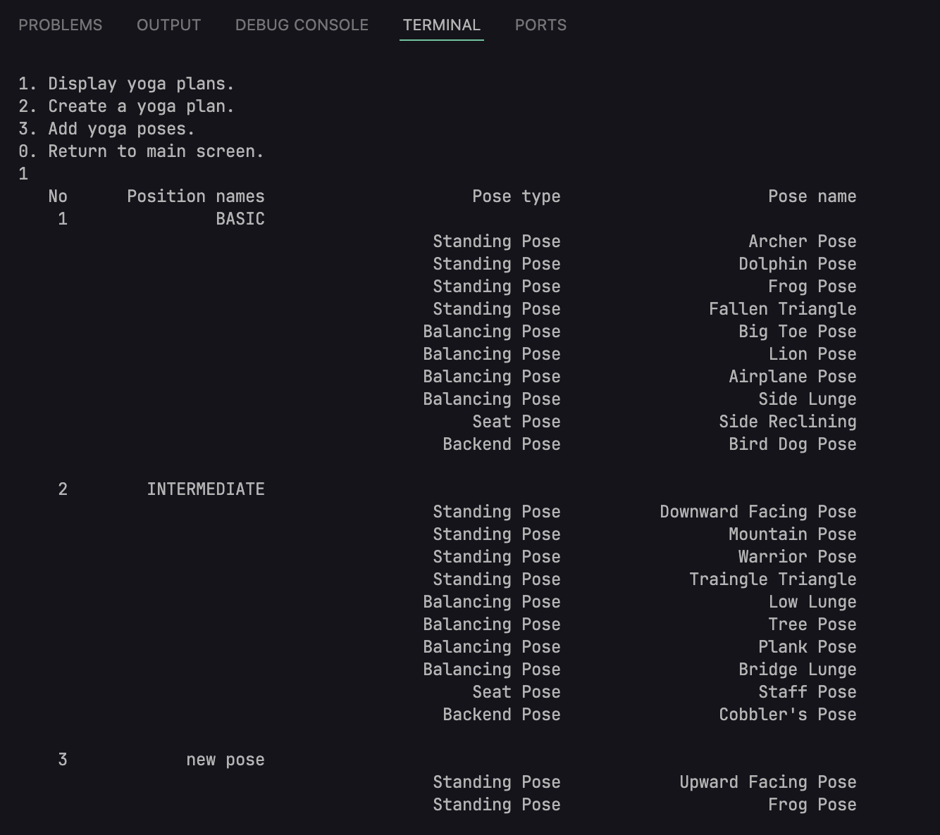

Figure – viewing pose plans after adding new poses

Here is the updated list after adding new yoga poses to new pose plan.

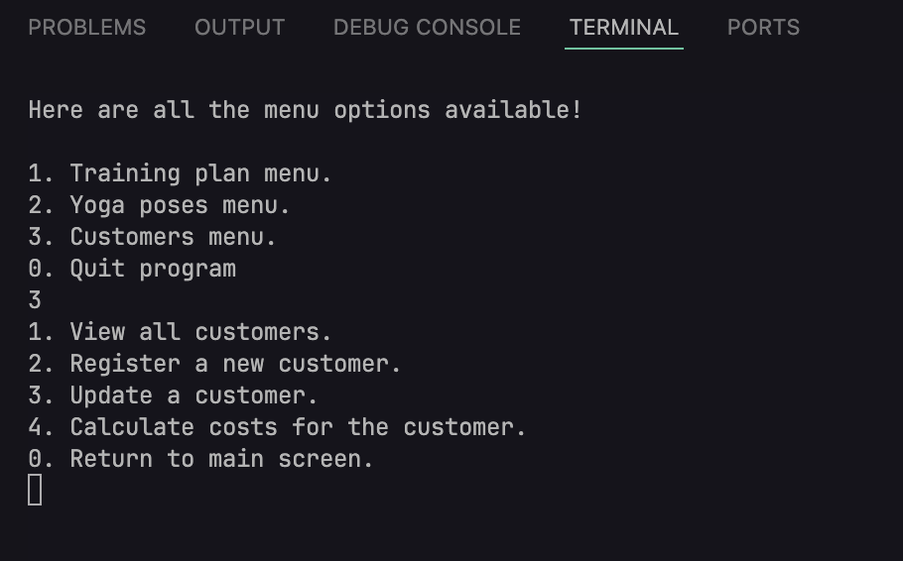

Figure – customer menu

Menu option 3 will open up customer menu.

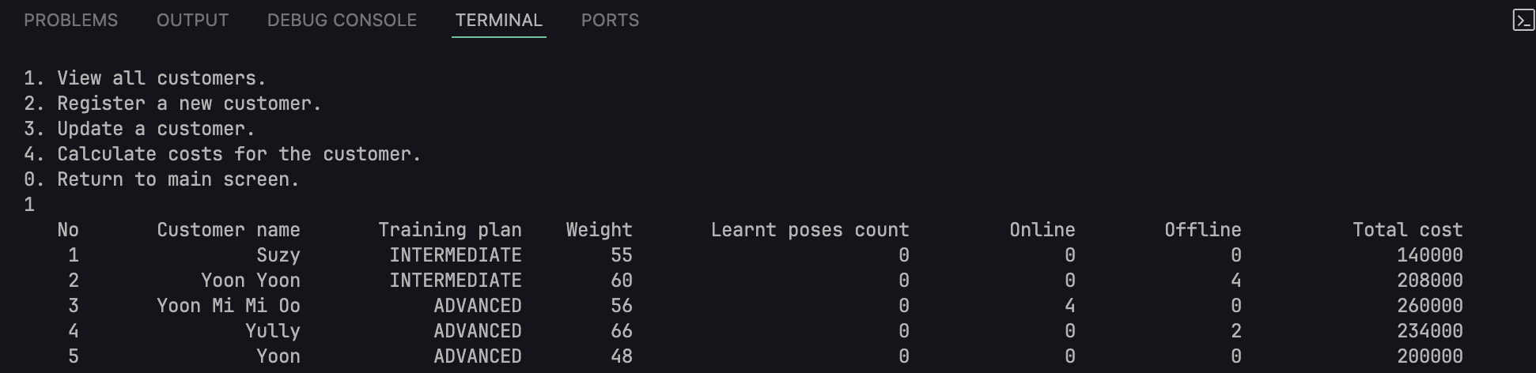

Figure – viewing all the customers

All the customers can be viewed from menu option 1.

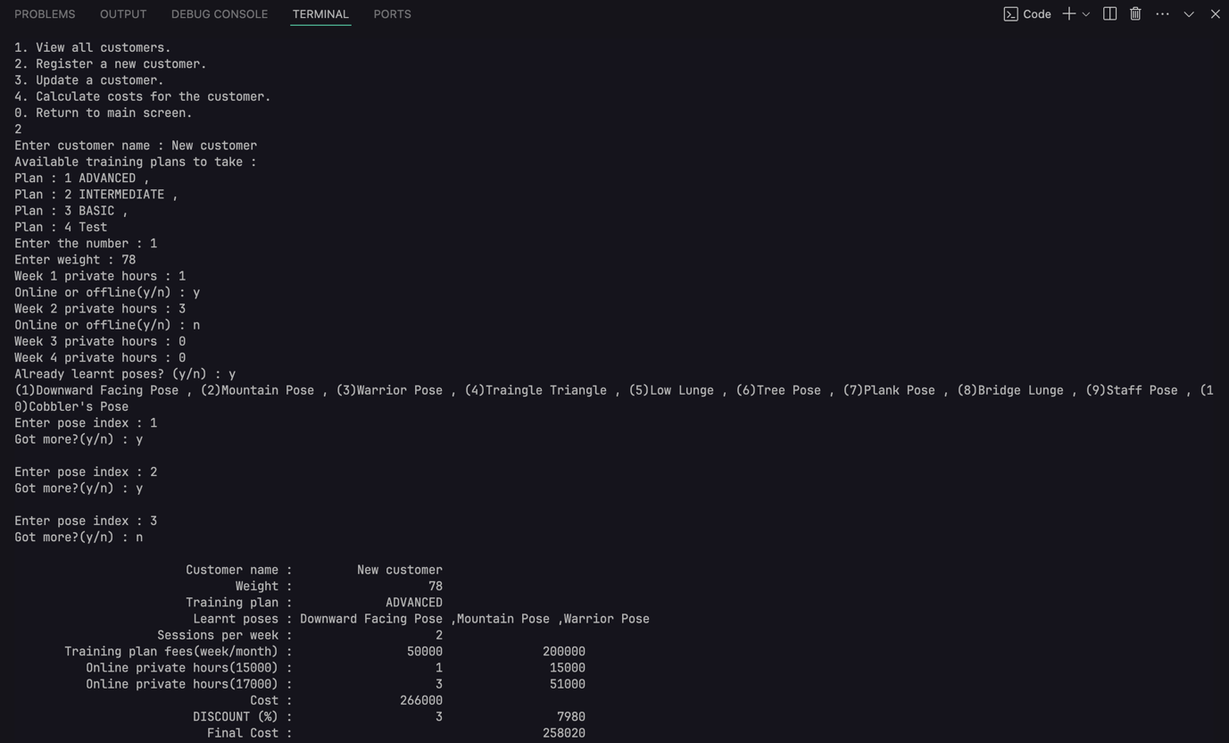

Figure – creating a new customer

New customer can be created by entering menu option 2. It will ask customer’s name, plan to be taken, weight, private hour, learnt poses if the customer is applying for intermediate and advanced plan. Finally, the customer voucher will be created and displayed.

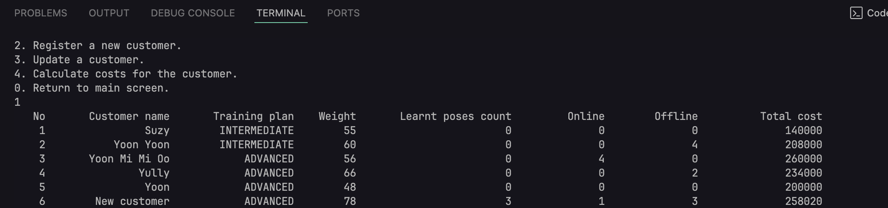

Figure – viewing customers after registering new customer

Newly added customer can be seen in the list of the customers.

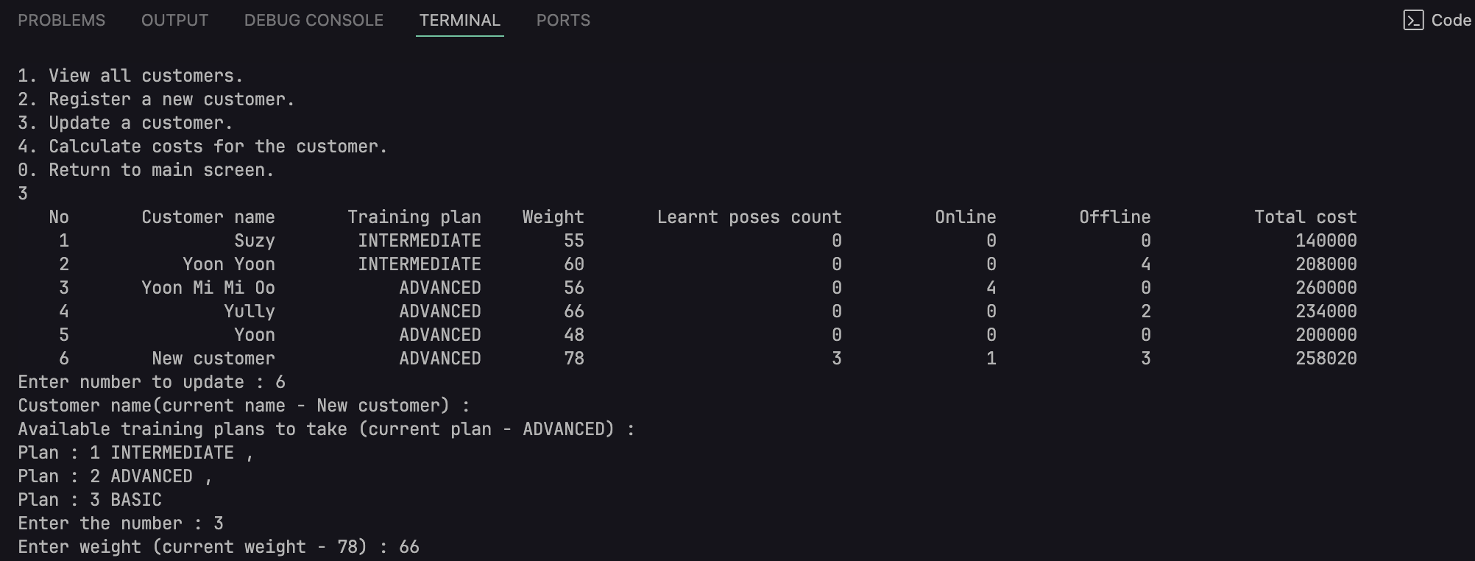

Figure – updating a customer

Updating the customer follows the same process as adding a customer except admin can’t change the name.

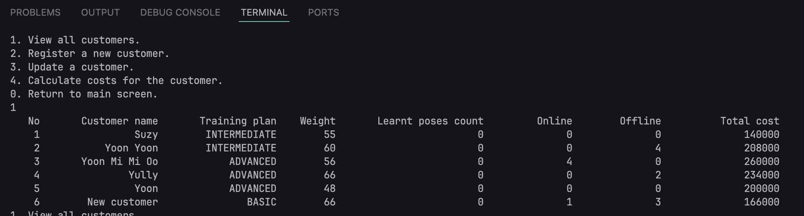

Figure – viewing after updating customer

Updated lists of the customers can be seen in the picture and the prices and all the values are updated too.

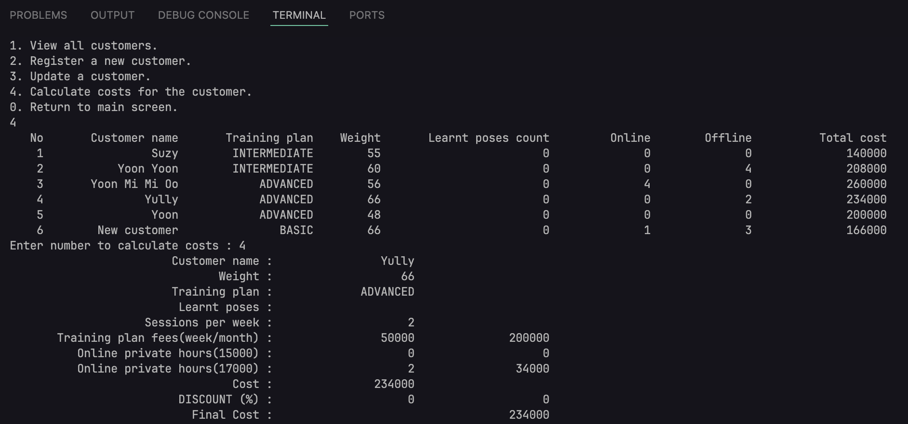

Figure – calculating cost details

Customer details can be viewed by the last menu option and entering the number of the customer that admins want to view. All the details such as plan, learnt pose count, learnt poses, discount and final price can be seen here.

# P5.

# Debugging

Debugging is the common technical term used to refer to a way of identifying, evaluating and correcting inabilities in a computer program that inhibits the normal performance of a given program. This is a crucial component of software development that entails a mode approach to identifying such issues, analysing the root cause of the error and then getting a solution to the issue to prevent such errors.

## Debugging facilities

### Breakpoints

Breakpoint debugging is one of the common techniques employed during the development of software where use of breakpoints to pause a program’s execution is done. This is made possible to help developers view the status of the program at any given time so that they can manipulate the variables, check the stack log, and the system memory.

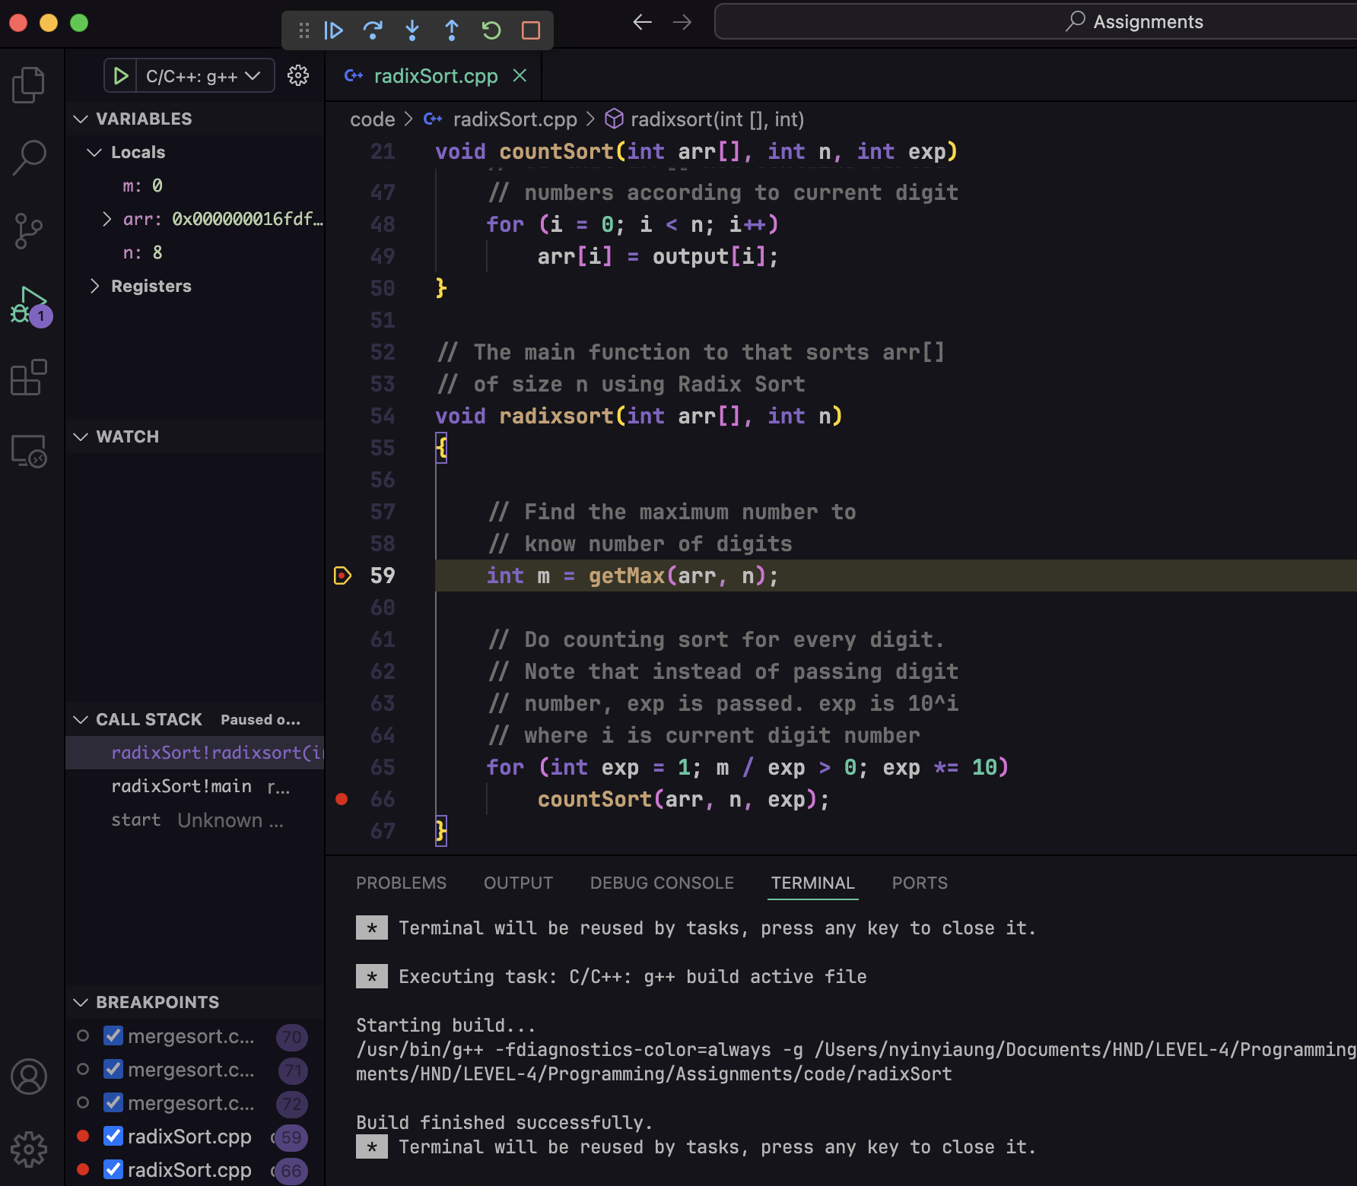

Figure: Breakpoint Example

### Integrated Debugger

Integrated debugger is defined as a set of tools that are developed and exist within Integrated Development Environments that helps in identifying, analysing, and resolving of an error that may be in a software application. The debugger function is one that is highly interlinked with several other aspects, and as such, serves as a highly significant piece in software development.

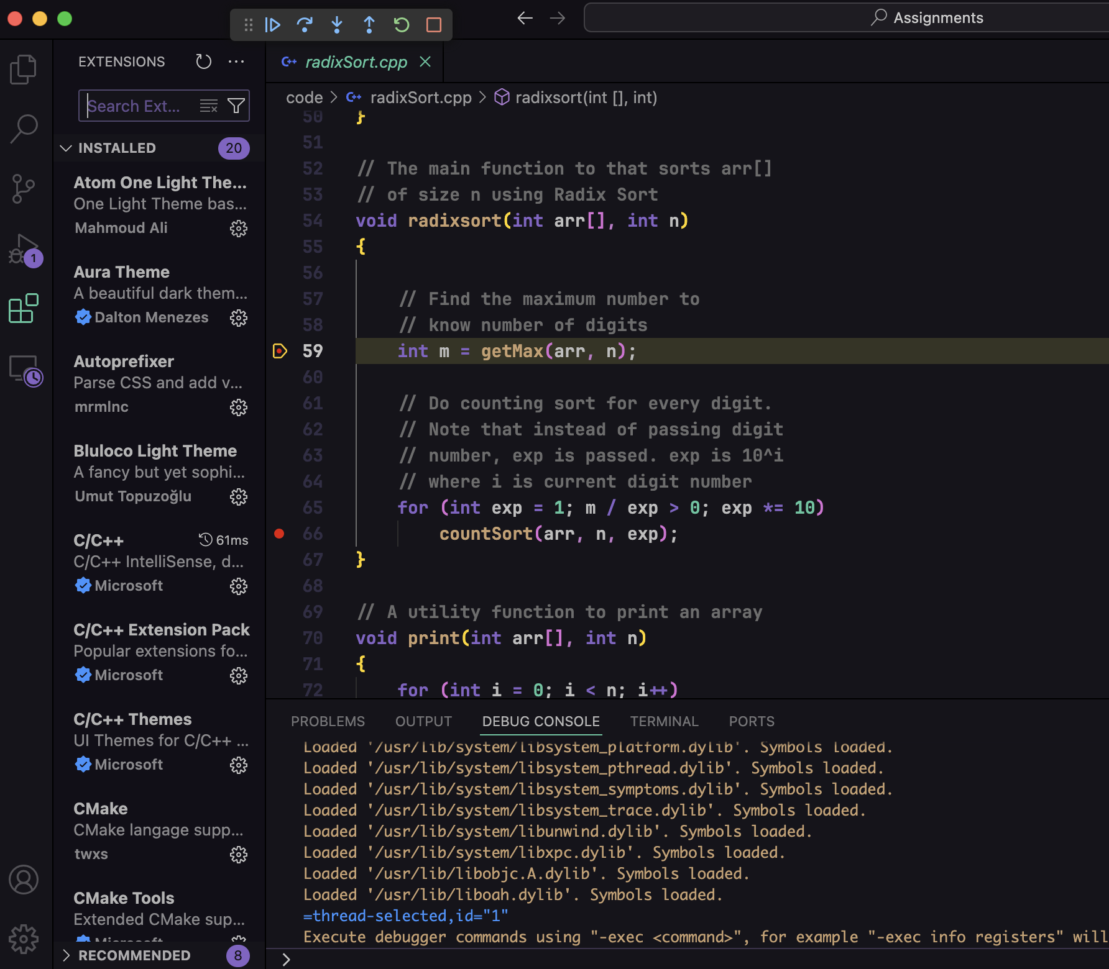

Figure: Integrated Debugger

### Variable and call stack inspection

The values of the current variables are displayed on the left side of the screen. The function to be executed after the current line is displayed in the call stack. Developers can learn about the future and present states of the function with the use of both technologies. It can make it much easier for developers to locate the errors.



Figure: Variable and call stack inspection

# P6.

## Coding standards

A Coding standard means the set of guidelines, rules, conventions, and best practices that are adopted while coding and in the maintenance phase of the software. These standards help in maintaining the structure, readability, reliability, and quality of code base particularly when implemented by large numbers of programmers. Coding standards are a set of rules governing how a certain code should be written, how should its variables and functions be named, and more importantly which set of rules within the contextual language or platform should be used.

## Naming conventions

Name conventions in coding standards relate to practices that pertain to how developers name variables, functions, classes, constants, and other aspects of code. These conventions are standard coding guidelines embraced globally as coding standards that seek to establish uniformity, coherence, and simplicity in coding and in software development projects.



Figure – naming conventions example

Naming conventions rules state to name the class and object names in PascalCase and variables and functions names in camelCase. The rule is used in the above of code block and all across the entire program. It improves the consistency and readability of the code.

## Indentation and formatting standards

Indention and formatting policies are the principles that contain the methodologies about how the code should be written, formatted and should be deliberately indented while developing software. These standards are of great importance to ensure the codes are presentable, easily understandable, and easier to manage whenever there are breaks or shifts in the coding process since many developers are working on the same code.



Figure – indentation and formatting

Indentation of 4 spaces for each level nesting is utilized in the program. For example, one level indent would have 4 spaces and 2-level indent would have 8.

## Version Control

Version control is the method used for incrementing, tracking, and recording changes in documents or files that occur over time in a systematic manner. Versioning organizes the history of changes in a logical order, and allows for review or version rollbacks if needed.

Version control eliminates the need for ad-hoc naming conventions, such as appending a date or user name to a file. Users no longer need to remember to manually version documents. Every change is captured as new document versions are added.

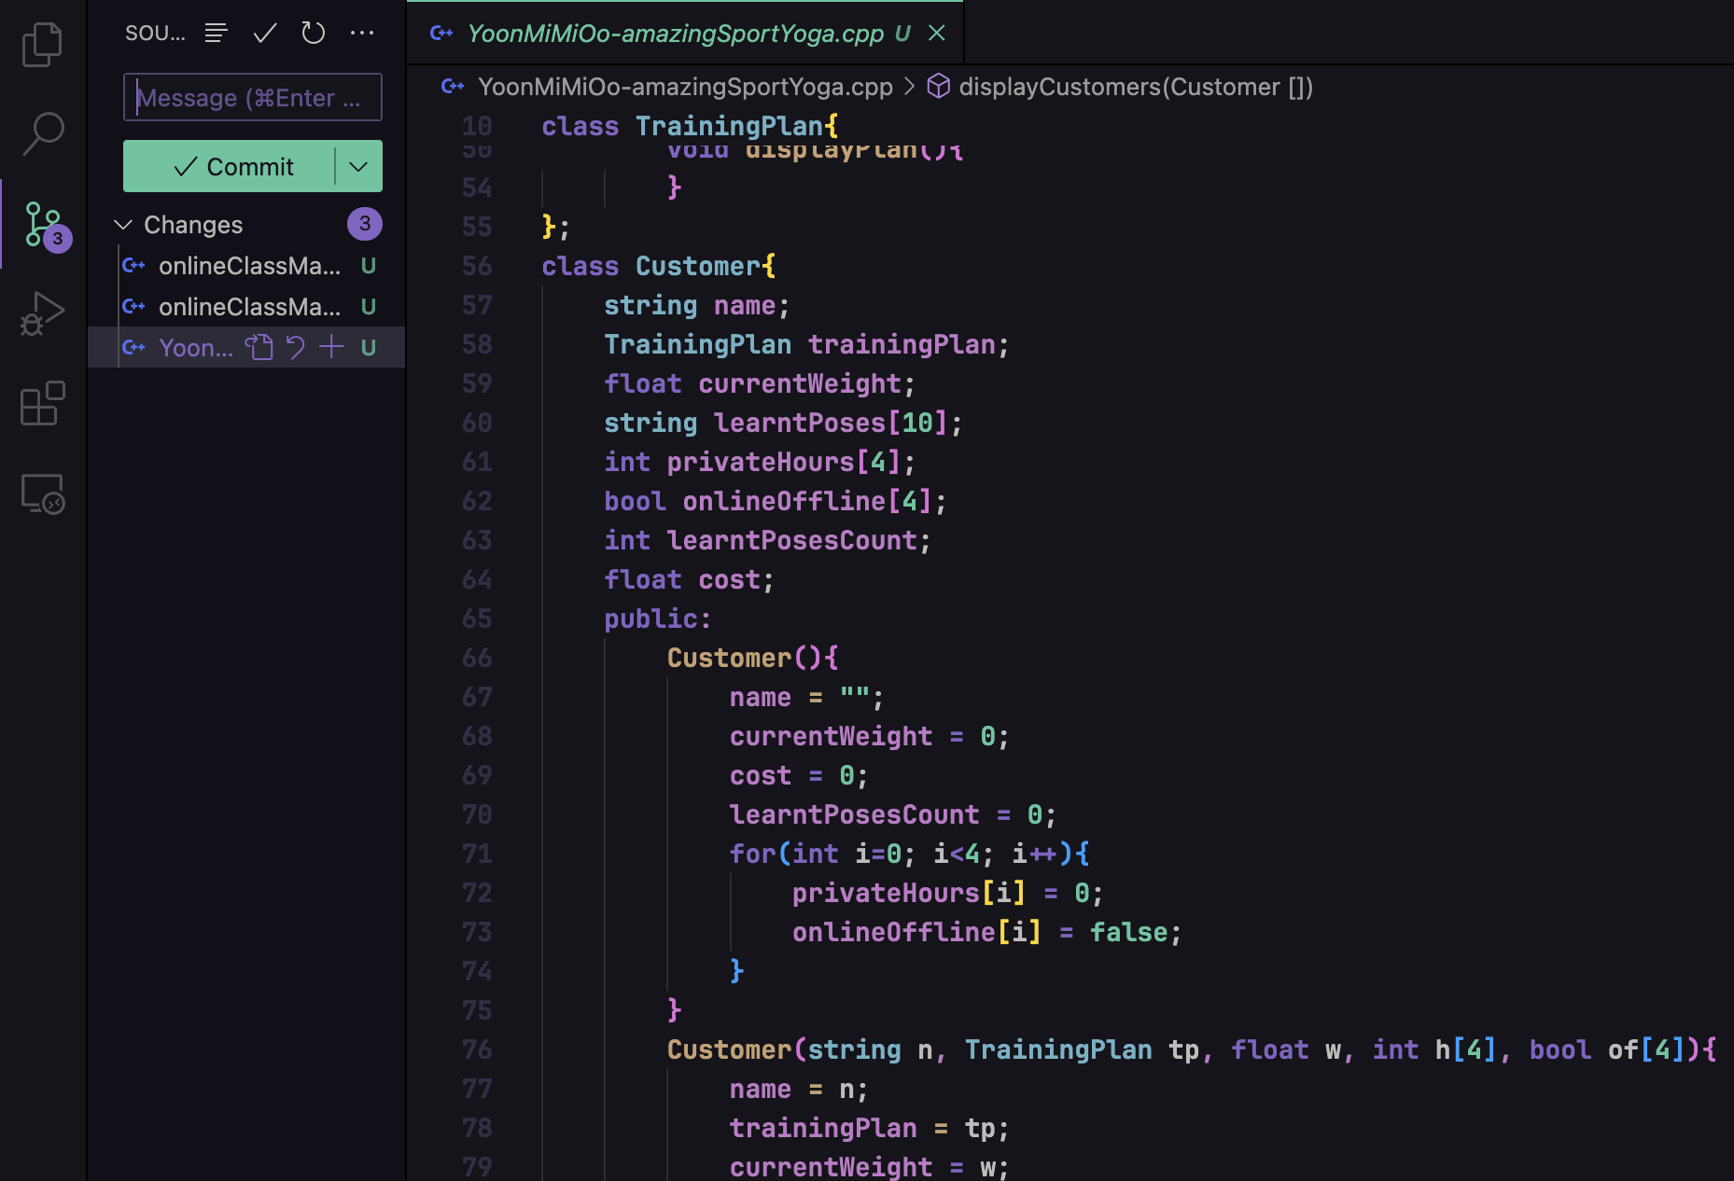

Figure – version control

Integrated version control system in the visual studio code is used to host the file on GitHub which can be used for code review, sharing, and version control.

# M3.

Radix Sort separates the components into buckets according to the value of each digit rather than directly comparing them. Radix Sort produces the desired sorted order by repeatedly sorting the items according to their significant digits, starting with the least significant and working up to the most significant.

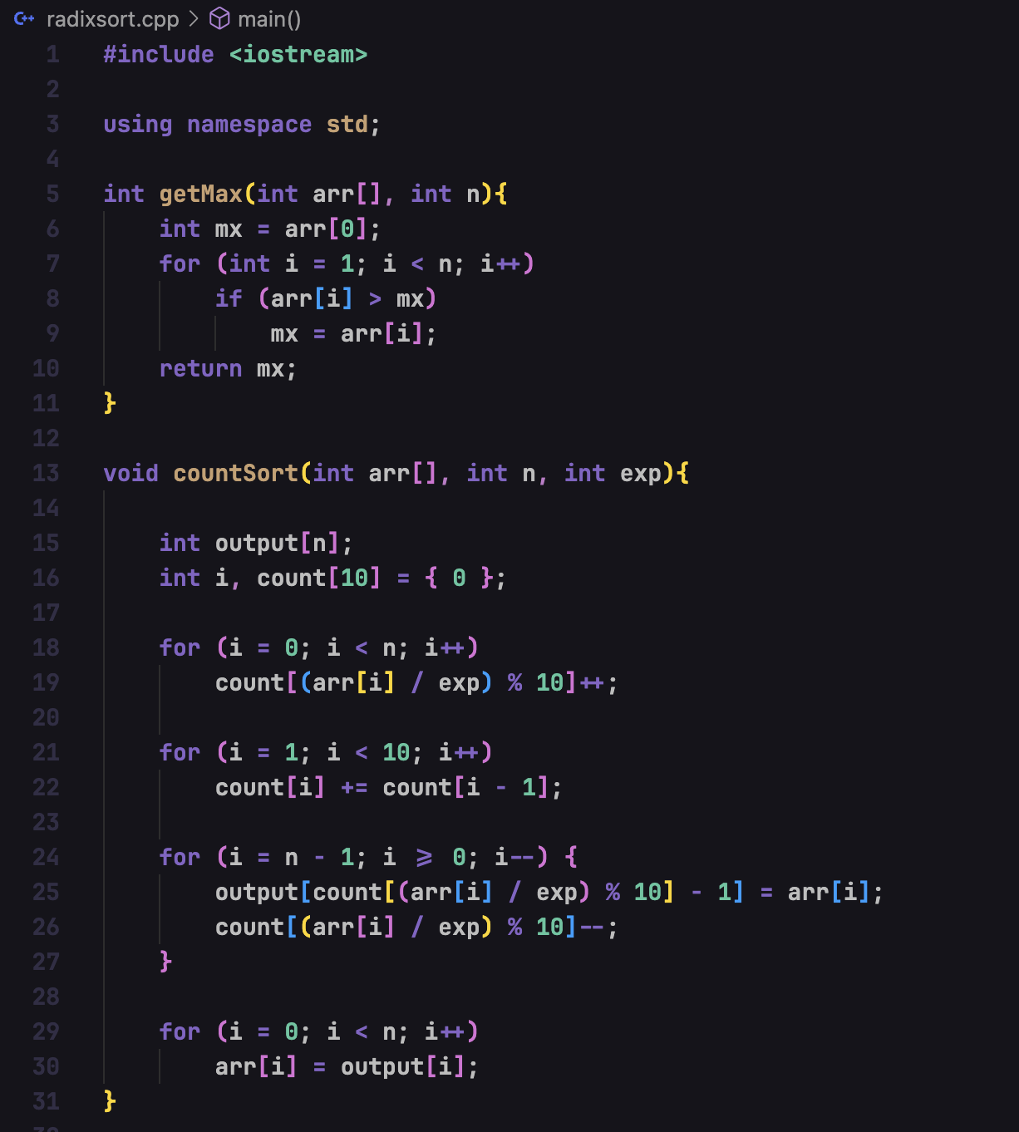

Figure – radix sort 1

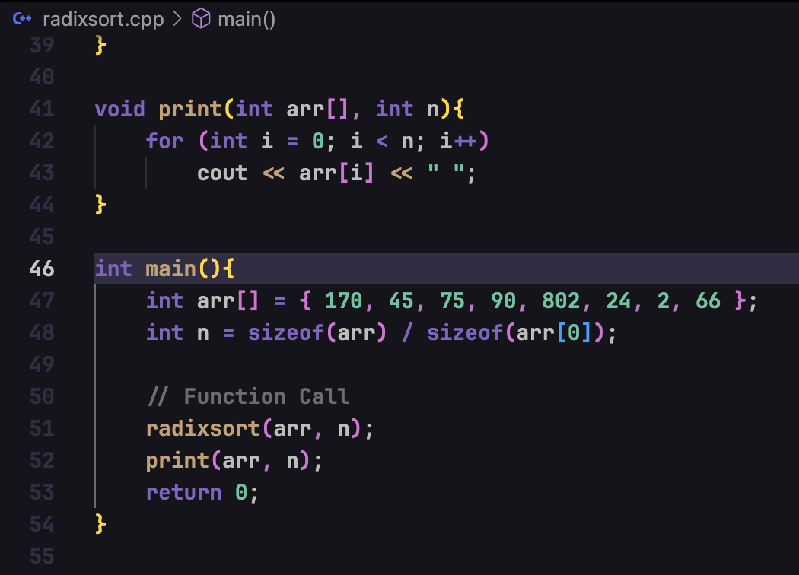

Figure – radix sort 2

## Possible errors when changing code

Code changes can lead to a variety of issues. The most noticeable and instant faults are those in syntax, which arise from typos or improper usage of language constructs and prevent the code from working properly during compilation or interpretation. When the code executes but behaves differently than intended because of faulty assumptions about the relationship between variables and functions or logical errors, conversely, semantic mistakes happen. Resulting in problems like inconsistent data or mismatched interfaces, when new code doesn't work well with pre-existing modules, integration failures may occur.

Data type mistakes are frequently a concern when employing an algorithm to a real-world problem. When developers try to change the data types from the algorithm to a real-world issue, these mistakes occur. Arithmetic operations, for instance, employ number data types, but the implemented operation may use a different kind of data. Incorrect data types can cause compilation errors and can be identified during the build process.

When an algorithm is applied to a practical issue, logical mistakes might arise. This occurs when the algorithm's reasoning is faulty due to coding errors. This could occur if the steps of the algorithm are not followed appropriately. Using the improper condition and index in a loop are a couple of instances.

## Usage of radix sort in the program

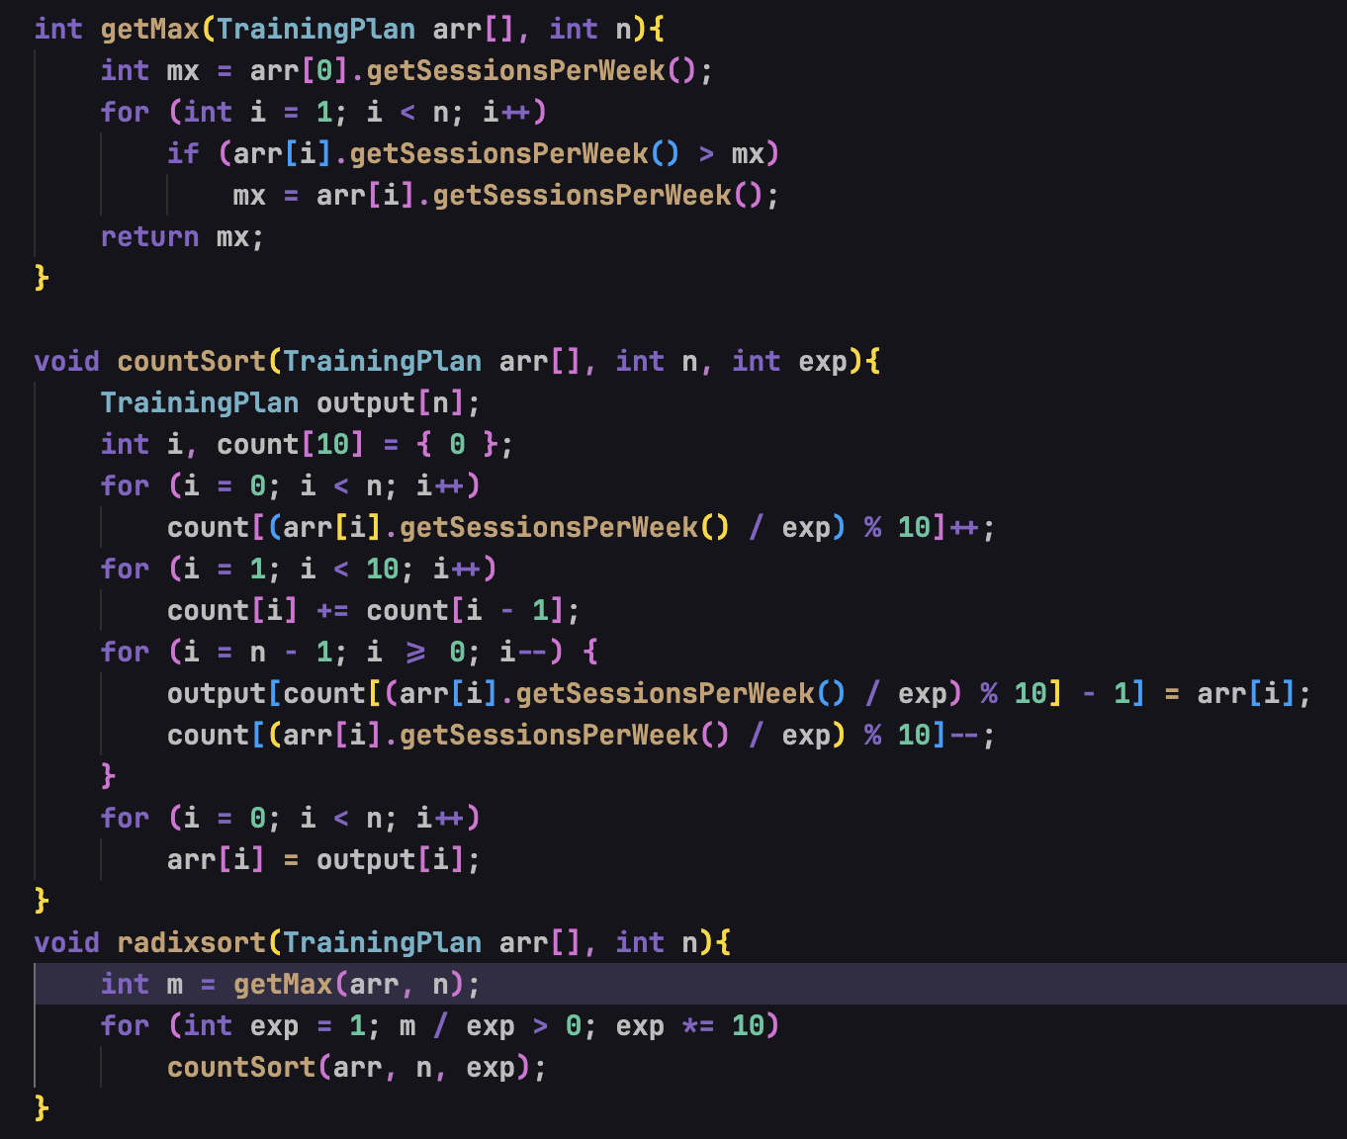

Figure – implementation of radix sort in the program

Radix sort is an efficient algorithm to sort integers. In this program, the sorting algorithm is used to sort the training plans by sessions per week. The training plan with lower sessions per week will be displayed first and the plans with higher sessions will be displayed after the lower one.

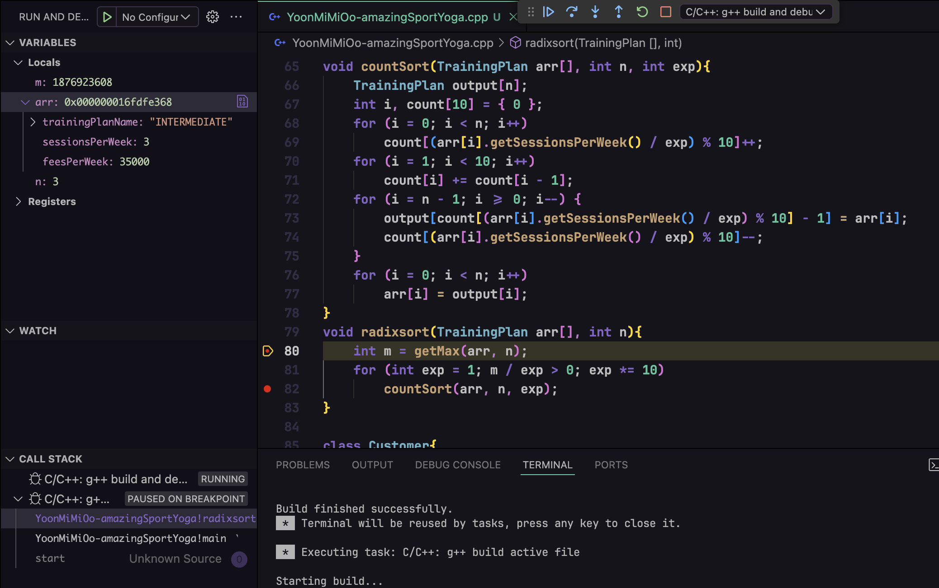

Figure – debugging stage 1

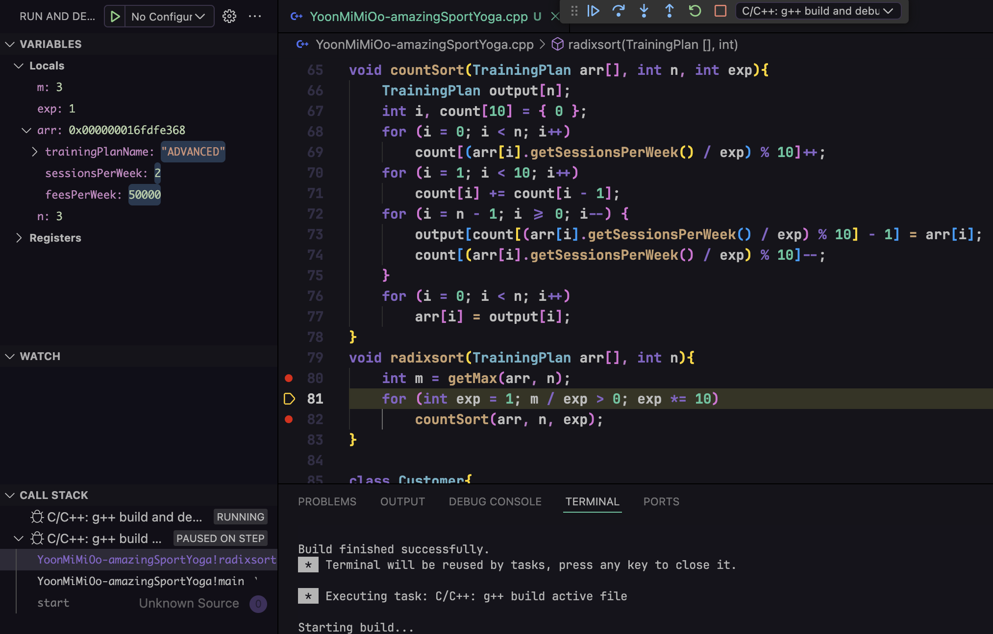

Figure – debugging stage 2

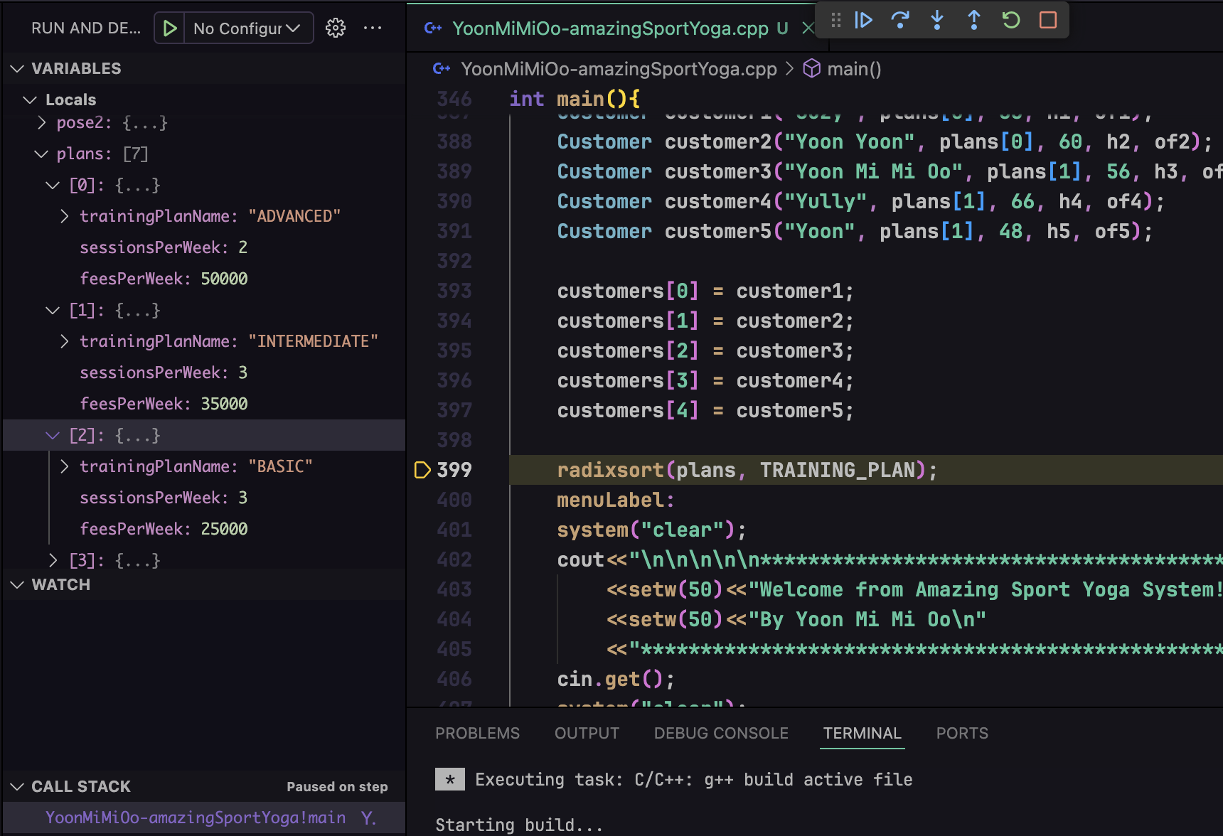

Figure – debugging stage 3

The above pictures show how the sorting has been performed through the array elements. It will check for each element in the radix algorithm approach and will be sorted by sessions per week.

# M4.

Debugging plays a crucial role in developing more secure and robust applications by offering several keys. Debugging plays a crucial role in developing more secure and robust applications by offering several key advantages:

Identifying Security Vulnerabilities: Debugging is useful to solve safety concerns in the source code like the buffer overflow, problem in input validation, and authentication problems. This is because if the above-mentioned vulnerabilities are not dealt with during the development phase, then an attacker will always find his or her way into the system and manipulate or exploit users’ sensitive information.

Enhancing Code Quality: This is because debugging forces developers to be more structured and write more efficient code. Debugging in particular is considered to contribute to increased code quality since developers get to spot and rectify mistakes that may make the code hard to work with in the long run.

Ensuring Reliability: Debugging aids in pulling out flaws that can result in application breakdown or diverse undesirable resulting behaviours or data corruptions. Debugging plays a part in maintaining the dependability of the code, which is beneficial for the overall perception of the website and for mitigating possible disruptions of the user experience.

Optimizing Performance: Debugging can also be used to find an area that is inefficient and taking a long time to run. The optimization of the sections that can be considered as the most crucial for the further performance is the initiative that can be undertaken by the developers.

Better Understanding of Code: This is especially important in terms of debugging, since a thorough knowledge of the concepts of the algorithm used in the application is very important. This can be done by developers pooling together in coming up with better design decisions as well as preventing coding defects, resulting in improved outcomes in the future.

Facilitating Continuous Improvement: Debugging is a cyclic process, and it should be approached as a constant process which will always have some sort of results, and not as a single event. Debugging involves the process of fixing the existing bugs and improving the code and with repeated attempts and regular debugging and practicing, the developers can make the application safer, more robust and faster.

# D3.

## IDE

An IDE, or Integrated Development Environment, enables programmers to consolidate the different aspects of writing a computer program. IDEs increase programmer productivity by combining common activities of writing software into a single application: editing source code, building executables, and debugging. Designed to encompass all programming tasks in one application, one of the main benefits of an IDE is that they offer a central interface with all the tools a developer needs

## Effects of using IDE

The use of IDEs has proved to be very effective when it comes to increasing productivity and improving code quality for software developers. All these options including real-time error checking, auto coding, and syntax are very useful since errors are detected as you write the code and the whole process is made faster. getting rid of bugs and integrating is easier with integrated debuggers; auto-formatting and auto-refactoring also plays an important part in this approach. The software development features like the version control and the dependency within the project management make it easy to manage the project and the dependencies in case of large and complicated code systems.

## Effects without IDE

Designing software development without an Integrated Development Environment (IDE) has socially influencing consequences on productivity and code. Some of the disadvantages without a couple of features such as real time error highlighting, auto-completion as well as integrated debugger are that the probability of getting the syntax wrong is high and so the debugging time is longer. Lack of integrated and valuable tools for formatting, refactoring, and project management hinders the flexibility within the development processes and amplifies the risk of creating code that is not standardized. Inexperienced programmers are deployed on projects and do not have the benefits of architecture, and coding standards that IDEs offer, which are crucial on steep learning curves.

## IDE comparison

# D4.

Coding standards contain recommendations on the most effective ways to write the code making it more consistent, reliable, and maintainable in the case of a whole group, project, or company. This suggests that coding standards are primarily geared towards making patterns of coding structures and styles readily recognizable. From the given snippet, in a few minutes of just scanning the code, developers are able to understand what the code is capable of doing. Coding standards weighs the code in a certain and definite manner making it easier for readers to comprehend, for debuggers to debug and minimizing on one’s errors. Nevertheless, it is not impossible to develop good codes and create reliable and high-quality products through practical measures like the aforementioned ones, for instance, the naming standards, the indentation rules, and documentation and other recommendations.

## Role and purpose of a coding standard in a team

A coding standard in context of a team defines the significance of the coding standard and its importance for the success of the task. Here are the key aspects:Here are the key aspects:

Consistency: Cleans up the code from other team members to conform to a certain coding style and standard making most of the codes in the project set out in the same way. This is due to the facts that the resembling code is more comprehensible, less complicated to repair and modify, and provides uniformity in its construction.

Readability: Enhances a proper coding standard by firstly defining the rules for naming, formatting and commenting. When the code is readable, there are fewer hours to spend on a code review or for gradually finding problems with the code.

Maintainability: Helps in making alteration to codes and maintaining the code since it tends to provide an organized structure. A simple code style is easier to analyze for a programmer and correct mistakes and add new functions and optimize and alter existing code.

## Role and purpose of a coding standard as an individual

As an individual developer, embracing coding standards serves several important roles and purposes:

Consistency: Maintaining standards is good because it makes your code easily understandable by aligning codes in terms of style and names. These are beneficial because it keeps your code consistent, making them easier to read and understand by your own eyes, or by any other coder who might encounter your code someday.

Readability: The coding standards facilitate the conception of unambiguous code by strategizing variables, indentation, and style conventions. It also minimizes the number of time spent in understanding the code written by you and also helps in bestowing quick looks whether there is any mistake or which part needs an improvement.

Maintainability: When coding, always bear in mind that the code is to be developed in a certain way that would make it easier to maintain or update in future. Freeman suggests that people appreciate when the structure and formatting of a software are homogeneous, because it helps them make alterations, extend capabilities, or fix bugs without generating extra problems.

# References

(No date) What is debugging? - debugging explained - AWS. Available at: https://aws.amazon.com/what-is/debugging/ (Accessed: 04 June 2024).

What is version control: Document locator knowledge (2024) Document Locator. Available at: https://www.documentlocator.com/resources/knowledge/what-is-version-control/ (Accessed: 06 June 2024).

(No date) What is debugging? - debugging explained - AWS. Available at: https://aws.amazon.com/what-is/debugging/ (Accessed: 04 June 2024).

Codacy (2024) Coding standards: What are they and why are they important?, Codacy. Available at: https://blog.codacy.com/coding-standards (Accessed: 10 June 2024).

Coding standards and guidelines (2024) GeeksforGeeks. Available at: https://www.geeksforgeeks.org/coding-standards-and-guidelines/ (Accessed: 10 June 2024).

MozDevNet (no date) Call stack - MDN web docs glossary: Definitions of web-related terms: MDN, MDN Web Docs. Available at: https://developer.mozilla.org/en-US/docs/Glossary/Call_stack (Accessed: 10 June 2024).